

**PROJECT REPORT ON**

***“HR51_PROPERTIES”***

**Submitted in partial fulfillment of the requirement for the award of the degree of Bachelor of Computer Application**

**(Batch: 2020-2023)**

**Submitted By: Name: Prakash Rawat**

**Enrollment No: 03450402020**

**Jagan Institute of Management Studies**

#### (Affiliated to Guru Gobind Singh Indraprastha University)



**Jagan Institute of Management Studies**

### PROJECT REPORT PROFORMA – BCA-VI SEMESTER

**CHAPTER-1 INTRODUCTION**

* Objective of the System
* Justification and need for the system
* Advantage of the system
* Previous work or related systems, how they are used.

### CHAPTER-2 REQUIREMENT ANALYSIS

* Analysis Study
* User Requirements
* Inquiry Form/Interviews
* Discussion with IT Experts
* Final Requirements

### CHAPTER-3 DESIGN OF THE SYSTEM

* Hardware, Software requirements
* System requirements
* Detailed System Specification (Module Wise)
* Block Diagram of the system
* DFDs/Algorithms/Flow Charts along with explanations/descriptions
* S/W Architecture

### CHAPTER-4 IMPLEMENTATION & CODING

* Operating System
* Languages
* S/W Tools

### CHAPTER-5 TESTING & TEST RESULTS

* Sample test data/ Output screen printouts etc. need to be presented with description

**CHAPTER-6 RESULTS & CONCLUSION**

**Jagan Institute of Management Studies**

**CERTIFICATE OF DISSERTATION (FACULTY MENTOR)**

This is to certify that this is a bonafide record of the project work done satisfactorily at Jagan Institute of Management Studies, Rohini by Mr. Prakash Rawat Enrollment No: 03450402020 in partial fulfillment of the requirement of BCA-VI Semester Examination.

This report or similar report on the topic has not been submitted for any other examination and does not form part of any other course undergone by the candidate.

Signature of Project Guide:

Name & Designation: Ms. Ankita Chopra

(Assistant Professor)

# CHAPTER 1 INTRODUCTION

* 1. Objective of the System
  2. Justification and need for the system
  3. Advantage of the system
  4. Previous work or related systems, how they are used.

## Chapter 1- Introduction

### OBJECTIVE OF THE SYSTEM

Real estate refers to property consisting of land, buildings, and other structures, along with the natural resources and assets that are associated with it. Whenever looking for a new property the main focus is on its location. As a location is a spatial entity and the real of the World Wide Web has spread across millions of households, so naturally, the Internet has become by far the best platform for real estate marketing today. The real estate system provides facility to the users to select any particular location and get all the necessary information about the properties which is based on selection of location.

The aim of this project is to develop a real estate system. This is a basic system where users can register then login and view property. The whole system will be managed by the admin also it give the facilitation to the users to communicate with each other and if needed it can easily hire a property agent for dealings through the system. So the admin can have all these details in his personal machine rather than having hundreds of registers. Real Estate Management System is to manage the details of Property, Property Type, Property Details, Location. It manages all the information about Property, Facility, Location, Property.

The project is totally build at administrative end and thus only the administrator is guaranteed the access. The purpose of the project is to build an application program to reduce the manual work for managing the properties. It tracks all the details about Property Details, Photos, Location.

### JUSTIFICATION AND NEED FOR THE SYSTEM

* + - **Accessibility and Convenience:** An online system allows potential buyers, renters, and real estate professionals to access property information anytime, anywhere. It eliminates the need for physical visits to real estate agencies or multiple phone calls, enabling users to search and view properties conveniently from their devices.
    - **Expanded Market Reach:** The online platform opens up opportunities for

real estate professionals to reach a broader audience beyond their local area. It enables them to showcase properties to potential buyers or renters from different locations, thereby increasing market reach and potential sales or rental prospects.

* + - **Efficient Property Management:** Managing a large inventory of properties, transactions, and client information manually can be cumbersome and prone to errors. An online system streamlines property management tasks, including listing properties, tracking inquiries, managing documents, and coordinating appointments. This efficiency saves time, reduces administrative burdens, and improves overall productivity.
    - **Enhanced Customer Experience:** Buyers and renters today expect a seamless and user-friendly experience when searching for properties. An online system provides advanced search functionalities, filters, property details, images, and virtual tours, offering a rich and interactive experience to potential customers. This enhances customer satisfaction and increases the chances of successful transactions.
    - **Data-driven Decision Making:** An online real estate system collects and stores a wealth of data related to properties, market trends, client preferences, and transaction history. By leveraging data analytics and reporting tools, real estate professionals can gain valuable insights into market conditions, buyer behavior, and pricing trends. These insights facilitate informed decision making and enable professionals to adapt their strategies accordingly.
    - **Transparency and Trust:** An online system promotes transparency by providing accurate and up-to-date information about properties, including pricing, availability, and property history. This transparency builds trust between buyers, renters, and real estate professionals, leading to stronger relationships and increased confidence in the transaction process.
    - **Integration with Ancillary Services:** An online system can be integrated with various ancillary services, such as mortgage lenders, property valuation services, legal services, and insurance providers. This integration simplifies the overall real estate transaction process, offering a one-stop solution for buyers and renters.

In summary, the real estate industry can greatly benefit from an online system due to its ability to enhance accessibility, market reach, efficiency, customer experience, data-driven decision making, transparency, security, and integration with ancillary services. By leveraging technology, real estate professionals can stay ahead in a competitive market and meet the evolving needs and expectations of clients in the digital age.

### ADVANTAGE OF THE SYSTEM

* + - It makes it easy to be used to generate income, such as through rental payments or leasing agreements. Generating income can help offset the cost of owning and maintaining the property and provide a source of passive income for the owner.
    - It offer a great user experience for its customers. This means making sure that the site is easy to operate and that all features are accessible without difficulty. It also means ensuring that the website looks and feels good, both on desktop and mobile devices.
    - It provide good and trustworthy property to customers and protect them from “Property Title Fraud”.

### PREVIOUS WORK OR RELATED SYSTEMS, HOW THEY ARE USED

There are several types of web applications that are used for the same purpose, such as:

* **Property Listing Platforms:** Websites like Zillow, Trulia, and Realtor.com have been developed as online platforms where real estate agents can list properties for sale or rent. These platforms provide comprehensive property details, photos and contact information

for interested buyers or tenants.

* **Property Management Systems:** These systems are used by property managers to streamline and automate various tasks related to property management, such as property listing, trends and financial reporting. They provide centralized platforms for managing multiple properties and optimizing operational efficiency.
* **Real Estate CRM:** Customer Relationship Management (CRM) software tailored for real estate helps agents and agencies manage client relationships, track leads, schedule appointments, and automate communication. It enables real estate professionals to organize their client database, monitor interactions, and enhance customer service.
* **Personal interaction:** Offline real estate relies on direct personal interaction between buyers, sellers, and real estate agents. Face-to-face meetings, property visits, and negotiations are common practices in offline real estate transactions.
* **Local market expertise:** Offline real estate agents have in-depth knowledge of the local market. They are familiar with the neighborhoods, property values, and market trends in their specific areas. This expertise helps them guide buyers and sellers effectively.
* **Physical property inspections:** In offline real estate, buyers have the opportunity to physically visit and inspect properties of interest. They can assess the property's condition, layout, and suitability for their needs. This hands-on experience allows buyers to make informed decisions.
* **Paper-based documentation:** Offline real estate transactions involve extensive paperwork, including contracts, agreements, and legal documents. These documents

are often signed physically and require physical presence for notarization and other formalities.

* **Local networking:** Offline real estate agents build strong local networks with other agents, brokers, and professionals in the industry. These networks help them discover off-market properties, obtain referrals, and collaborate with others for successful transactions.
* **Local advertising and marketing:** Offline real estate relies on traditional marketing channels such as newspaper ads, flyers, billboards, and local signage. These methods target the local community and potential buyers who may not be actively searching online.
* **Trust and personal relationships:** Offline real estate transactions emphasize building trust and fostering personal relationships. Buyers and sellers often prefer working with agents they know or have been recommended by friends or family, creating a sense of security and reliability.
* **Negotiations and face-to-face communication:** Offline real estate involves direct negotiations between buyers, sellers, and agents. Face-to-face communication allows for clearer understanding, immediate feedback, and better negotiation outcomes.

While online platforms have gained popularity in recent years, offline real estate continues to play a crucial role in many markets, leveraging personal connections and local expertise to facilitate successful transactions.

# CHAPTER 2 PROJECT DESCRIPTION

* 1. Analysis Study
  2. User Requirements
  3. Discussion with IT Experts
  4. Final Requirements

## Chapter 2- REQUIREMENT ANALYSIS

### ANALYSIS STUDY

To evaluate the effectiveness, benefits, and potential of the HR51 Properties web application, a combination of quantitative and qualitative methods is used. These methods provide valuable insights and data for the analysis. Some of the methods employed include:

* User Surveys: Surveys are conducted to gather feedback from users of the HR51 Properties application. The surveys include questions about user satisfaction, ease of use, functionality, and perceived benefits. This helps gauge user opinions and identify areas of improvement.
* User Interviews: In-depth interviews are conducted with a select group of users to gather detailed insights into their experiences with the HR51 Properties application. These interviews allow for a deeper understanding of user needs, challenges faced, and suggestions for enhancements.
* Data Analysis: Usage data and analytics collected from the application are analyzed to understand user behavior, engagement levels, and patterns of usage. This data provides quantitative insights into the effectiveness and usage trends of the application.
* Cost-Benefit Analysis: A cost-benefit analysis is conducted to assess the financial implications of using the HR51 Properties application. This includes evaluating the costs of implementation, maintenance, and training, as well as quantifying the benefits such as increased productivity, cost savings, and improved customer satisfaction.
* Stakeholder Feedback: Feedback from stakeholders such as real estate

agents, property owners, and administrators is gathered to understand their perspectives on the HR51 Properties application. Their input helps assess the application's impact on their workflow, efficiency, and overall business operations.

By utilizing these quantitative and qualitative methods, the analysis study aims to

provide a comprehensive evaluation of the HR51 Properties application. The results will help identify strengths, weaknesses, user satisfaction levels, and opportunities for enhancement, ultimately contributing to maximizing the application's effectiveness and potential in the real estate industry and It will also help to develop the application to the best of the abilities and also as per the standard required by the users of the application.

### USER REQUIREMENTS

User wants to create an application with three important targeted users (admin, staff, and website user), here are some considerations for each user type:

* Admin:

- Role: The admin user has administrative privileges and controls the overall functioning of the application.

- Features: The admin should have access to features such as user management, content management, and staff management.

- Responsibilities: The admin user is responsible for managing user accounts, setting permissions and access levels, monitoring system etc.

* Staff:

- Role: Staff members are individuals who work within the organization using the application.

- Features: Staff users should have features tailored to their specific job roles, such as property management, client management, task management, and communication tools.

- Responsibilities: Staff users may be responsible for updating property listings, managing client interactions, scheduling appointments, and collaborating with other staff members.

* Website User:

- Role: Website users are individuals who visit the application's website to search for properties or access information.

- Features: Website users should have features that facilitate property search, filtering, property details, and contact options.

- Responsibilities: Website users primarily engage with the application for

property search, viewing property details, and reaching out to the staff for inquiries or appointments.

In addition to the aforementioned features, there are basic requirements that should be considered. These include a feedback form where users can submit their honest opinions about the application, a contact page that allows users to communicate with the respective team for any inquiries, and a profile page that provides information about the user and includes an option for residents to reset their passwords.

### DISCUSSIONS WITH IT EXPERTS

During the requirement elicitation process, our mentor and team members discussed what could be a good set of requirements for our real estate project. We discussed the development environment, major modules distribution, skills required, and learning platforms. Also we discussed about the what would be the additional functionality which could be added later on.

The project was divided into nine modules-:

1. **Property Listings:** This module allows users to view and search for properties based on various criteria such as location, price range, property type, and features. It displays property details, including descriptions, images and contact information.
2. **Property Search:** This module enables users to search for properties using specific search criteria, filters, and sorting options. It provides a user-friendly interface to refine property search results based on preferences.
3. **Property Details:** This module presents comprehensive details about individual properties, including specifications, amenities, location maps, floor plans and pricing information. It allows users to explore properties in-depth.
4. **Property Scheduling Module:** In a real estate website facilitates the scheduling and management of property appointments or viewings for interested clients.

1. **User Registration and Profiles**: This module facilitates user registration, login, and the creation of user profiles.
2. **Contact and Inquiry Forms:** This module allows users to contact property owners, real estate agents, or brokers through inquiry forms or contact information provided on the website. It enables users to request more information, schedule property viewings, or ask specific questions.
3. **Staff Panel Module:** The Staff Panel module in a real estate website is designed to cater specifically to the needs of staff members or agents who work within the real estate. It provides them with a dedicated platform to manage their tasks, clients, properties, and other aspects of their work.
4. **Testimonials and Reviews:** This module showcases testimonials and reviews from satisfied customers or clients, highlighting positive experiences and establishing trustworthiness.
5. **Admin Panel Module:** This module in a real estate website provides administrators with a centralized platform to manage and control various aspects of the website.

### FINAL REQUIREMENTS

* Adding Registration users to the database and saving their data.
* Provide the users with their respective home screens based on their roles after they log in.
* List all the properties associated with the real estate system.
* Retrieves property data from the database, applies search filters, and displays a list of matching properties to the user.
* Customized dashboard or landing page with relevant information, quick links, and access to specific features or functionalities based on the user's role.

To implement these functionalities, you would need to design and develop the necessary backend and frontend components, including database management, user interface design, and programming logic. Additionally, proper security measures should be implemented to protect user data and prevent unauthorized access.

# CHAPTER 3 DESIGN OF THE SYSTEM

* 1. Hardware and Software Requirements
  2. System Requirements
  3. Detailed System Specification (Module Wise)
  4. Block Diagram of the system
  5. DFDs/Algorithms/Flow Charts along with explanations/descriptions.
  6. S/W Architecture

## Chapter 3- DESIGN OF THE SYSTEM

### HARDWARE AND SOFTWARE REQUIREMENTS

* HARDWARE REQUIREMENTS:-
* RAM (Memory):
  + Minimum 4 GB RAM.
* CPU (Processor):
  + Minimum Intel Core i3 or AMD.
* Disk Space:
  + 8 GB of available disk space
* Screen Resolution:
  + 1024 X 768 Pixels Screen Resolution.

* SOFTWARE REQUIREMENTS:-
* Operating System:
  + Windows: Microsoft Windows 8 Home Basic
* Database:
  + SQLite
* Programming language:
  + Python-3
  + Django-5
  + Bootstrap-5

### SYSTEM REQUIREMENTS

#### Operating System:

* Windows 8/10/11
* Mac OS: Mac OS X 10.10 or later.

### DETAILED SYSTEM SPECIFICATION (MODULE WISE)

### Workflow of the real estate application for the three major users: admin, staff, and user.

### 1. Admin:-

### - The admin has overall control and management authority over the application.

### Modules for Admin:

### User Management:

### Admin can create and manage user accounts.

### They can add new users, activate or deactivate accounts, and set user roles and permissions.

### Property Management:

### Admin can manage property listings.

### They can add new properties, edit property details, update availability status, and remove properties from the listing.

### Staff Management:

### Admin can manage staff members.

### They can add new staff members, permissions, and manage their profiles.

### 2. Staff:

### - Staff members assist in property management, client interaction, and day-to-day operations of the real estate business.

### Modules for Staff:-

### Property Listing Management:

### Staff members can manage their assigned property listings.

### They can add new properties, edit property details, update availability status, and view inquiries related to their listings.

### Appointment Management:

### Staff members can schedule and manage property viewings and appointments with clients.

### They can coordinate appointment timings.

### Keeps a record of past appointments, including details such as the property viewed, the user's name, date.

### 3. User:-

### - Users are individuals looking for properties or seeking information on the real estate website.

### Modules for User:

### Property Search:

### Users can search for properties based on various criteria such as location, price range, property type, etc.

### The search module retrieves and displays relevant property listings.

### Property Appointment:

### The module checks the availability of the property. It ensures that there are no scheduling conflicts and that the property is available for viewing at the requested time.

### Property Details:

### Users can view detailed information about a specific property.

### This module provides property descriptions, images, videos, pricing details, and contact information for inquiries.

### Contact/Inquiry:

### Users can contact the staff or property owner through the website.

### This module enables users to send inquiries, schedule appointments, or request additional information about a property.

### BLOCK DIAGRAM OF THE SYSTEM

**FIG 1: BLOCK DIAGRAM**

The block diagram provides a high-level representation and can serve as a starting point for further discussions and detailed system design. Visual representation that illustrates the components and their interactions within a system. In the context of a real estate system, a block diagram can help provide an overview of the major functionalities and subsystems involved. Here's an example of a block diagram for a real estate system

* 1. **DFDS / ALGORITHMS / FLOW CHARTS ALONG WITH EXPLANATIONS**

**/ DESCRIPTIONS**

* + 1. **USECASE DIAGRAM**

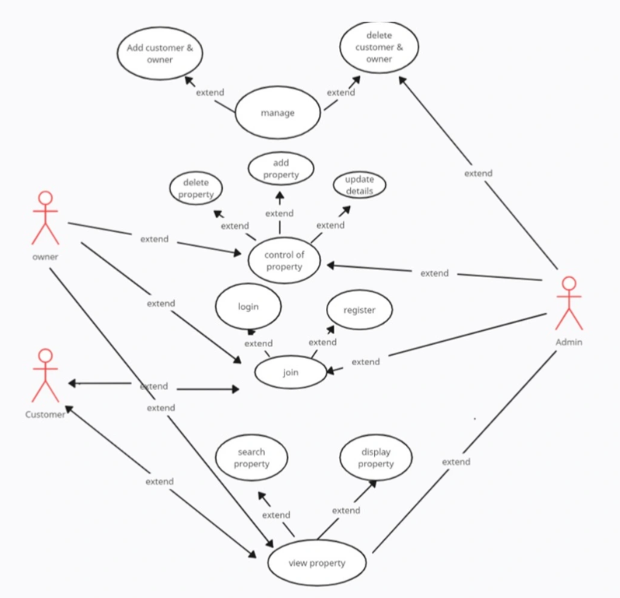

**FIG 2: USECASE DIAGRAM**

A use case diagram is a graphical depiction of a user's possible interactions with a system. A use case diagram shows various use cases and different types of users the system has and will often be accompanied by other types of diagrams as well. The use cases are represented by either circles or ellipses.

In Unified Modeling Language (UML), a use case is a written description used in software development and other fields. The use case describes how the tasks are performed in the systems or applications by the user. It summarizes the response of the actors with the system. An effective use case represents the scope, scenarios where user interacts with the system. Use cases provide a user- centric perspective on an application by illustrating that how it provides the response to the user’s requests and interactions.

Above is the use case diagram of our application that is summarizing the activities that can be done on our platform and its user details. It basically depicts the graphical representation of the system’s behavioral structure. The users can perform various functions on the application as you can see in the diagram. According to the functions performed, admin, staff, user will be providing the output of the performed functions.

### DATA FLOW DIAGRAM

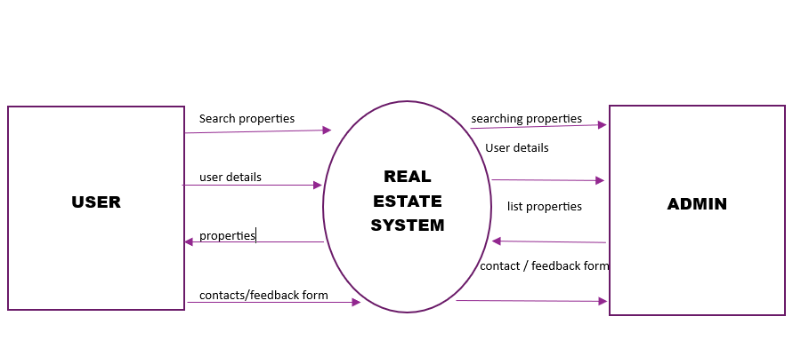

**FIG 3: DFD 0**

A data flow diagram is the visual representation of information flows within the system. It shows how the data enters and exits the system, where the data is stored etc. The DFD 0 provides an overview of the system. It doesn’t provide any internal workings of the system. The DFD 1 provides more detailed view of the system by breaking down the major processes that are identified in DFD 0. The DFD 2 is similar to DFD 1 and provides the details of the sub-processes also.

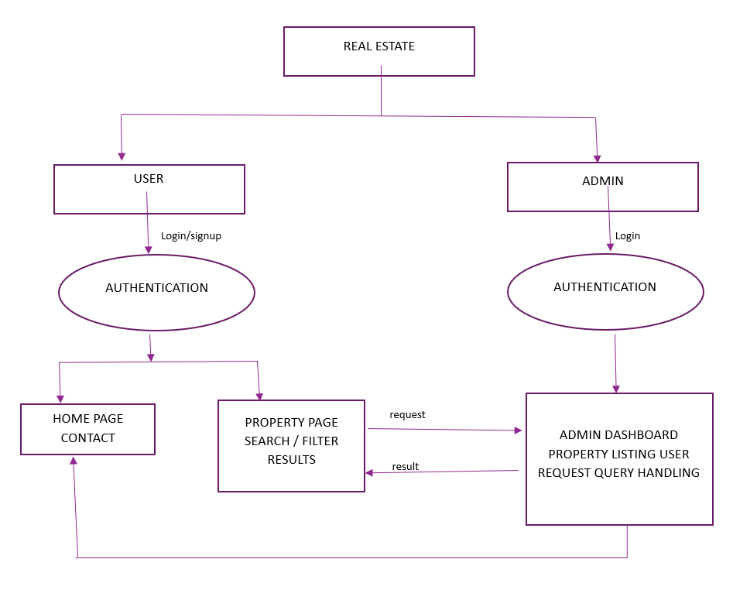

**FIG 4: DFD 1**

In DFD 1, the context diagram is decomposed into multiple bubbles/processes. In this level, we highlight the main functions of the system and breakdown the high-level process of DFD 0 into subprocesses.

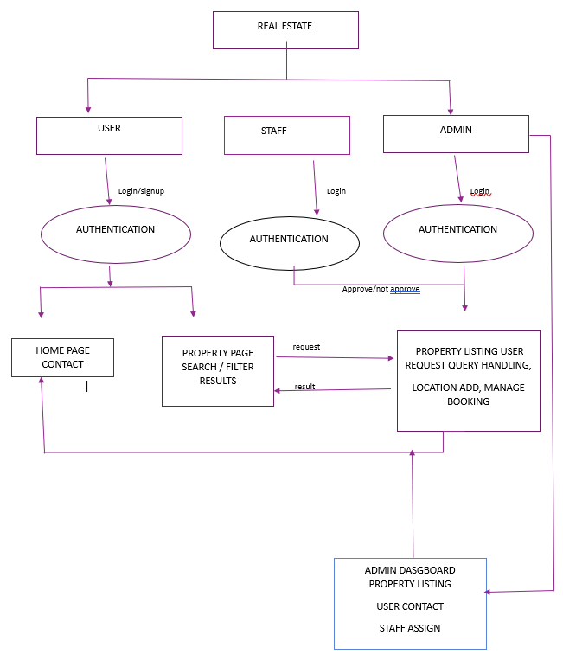

**FIG 5: DFD 2**

This level two data flow diagram (DFD) template can map out information flow, visualize an entire system, and be shared with your stakeholders.

### ENTITY-RELATIONSHIP DIAGRAM

### 

**FIG 6: ER DIAGRAM**

Entity Relationship Diagram is also known as ERD, ER Diagram or ER Model. It is a high level data model. It is used to define the relationship between different entities. It also develops a very simple and easy to design view of data. It describes in brief that how the different entities are related to each other.

### FLOW CHARTS

A flow chart is a graphical or symbolic representation of a process. Each step in the process is represented by a different symbol and contains a short description of the process step. The flow chart symbols are linked together with arrows showing the process flow direction. Given below are the 3 flowcharts of 3 different targeted users of our applications that depict the flow of web application.

**CUSTOMER:-**

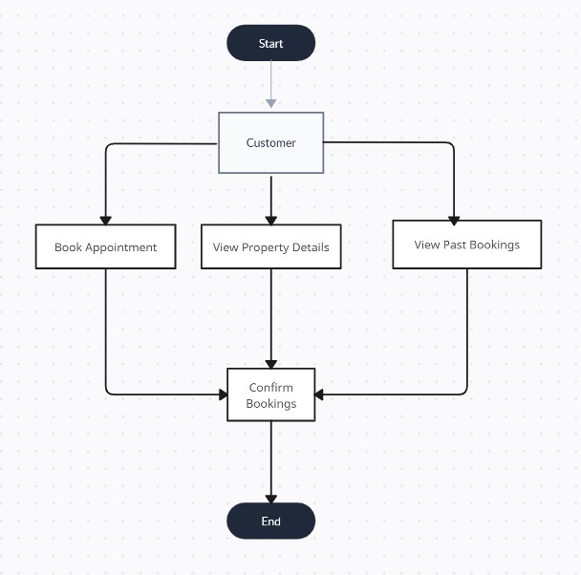

Booking a property, viewing a property, and handling past bookings.

Booking a Property: This process involves gathering property requirements from the customer, searching for available properties that meet those requirements, selecting a desired property, checking its availability.

Viewing a Property: Here, customers explore different property options, schedule viewings, visit the properties, evaluate their features.

Past Book Property: This process focuses on actions related to past bookings. Customers can request booking details, retrieve booking information such as dates and property details.

**STAFF:-**

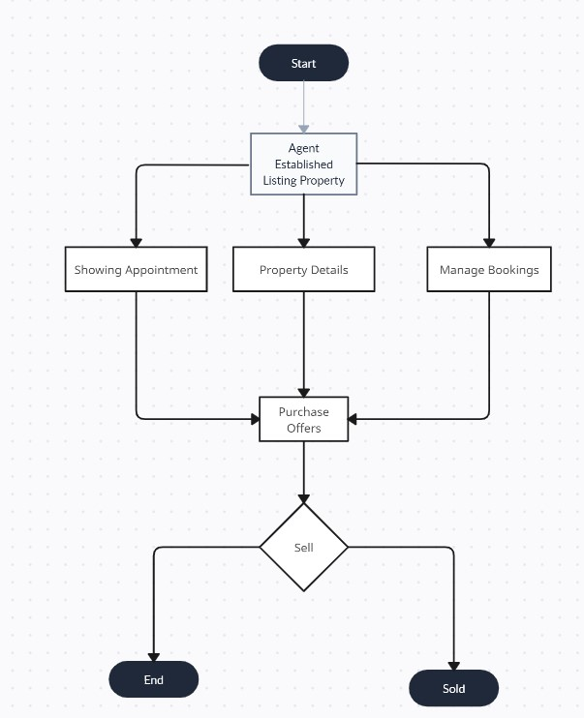

They handle all the relevant information about the property. This may include property features, descriptions, pricing, and other relevant details. Once the property details are managed, the staff moves on to "Manage Property Bookings." Here, they handle the booking process, including checking availability, making reservations, and managing any changes or cancellations. After managing the property bookings, the staff proceeds to "Showing Appointment Description."

ADMIN:

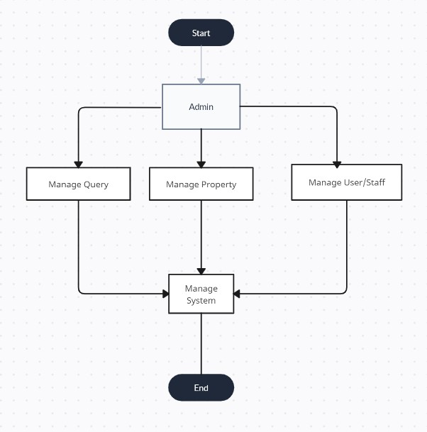

The admin can start by managing users and staff, which includes creating, updating, deleting, and viewing their details.

The admin can handle queries by receiving them, assigning them to staff members, following up on their progress, resolving them, and eventually closing them. The admin can also view the history of queries for reference or analysis purposes. They can manage properties by adding new properties, updating existing ones, deleting properties when necessary, and viewing detailed information about each property. The admin can search for specific properties about properties, and manage property listings, which may involve tasks such as publishing or removing listings.

### SOFTWARE ARCHITECTURE

This Project Software Architecture based on MVT:-

* Model: Represents the data structure and business logic of the application. It defines the data models, database interactions, and other functionalities related to data handling.
* View: Handles the logic for processing and responding to user requests. It retrieves data from the models, applies any necessary transformations or computations, and passes the processed data to the template for rendering.
* Template: Defines the presentation layer of the application. It contains HTML, along with placeholders and template tags, to dynamically render data received from the views. Templates allow for the separation of presentation and logic.

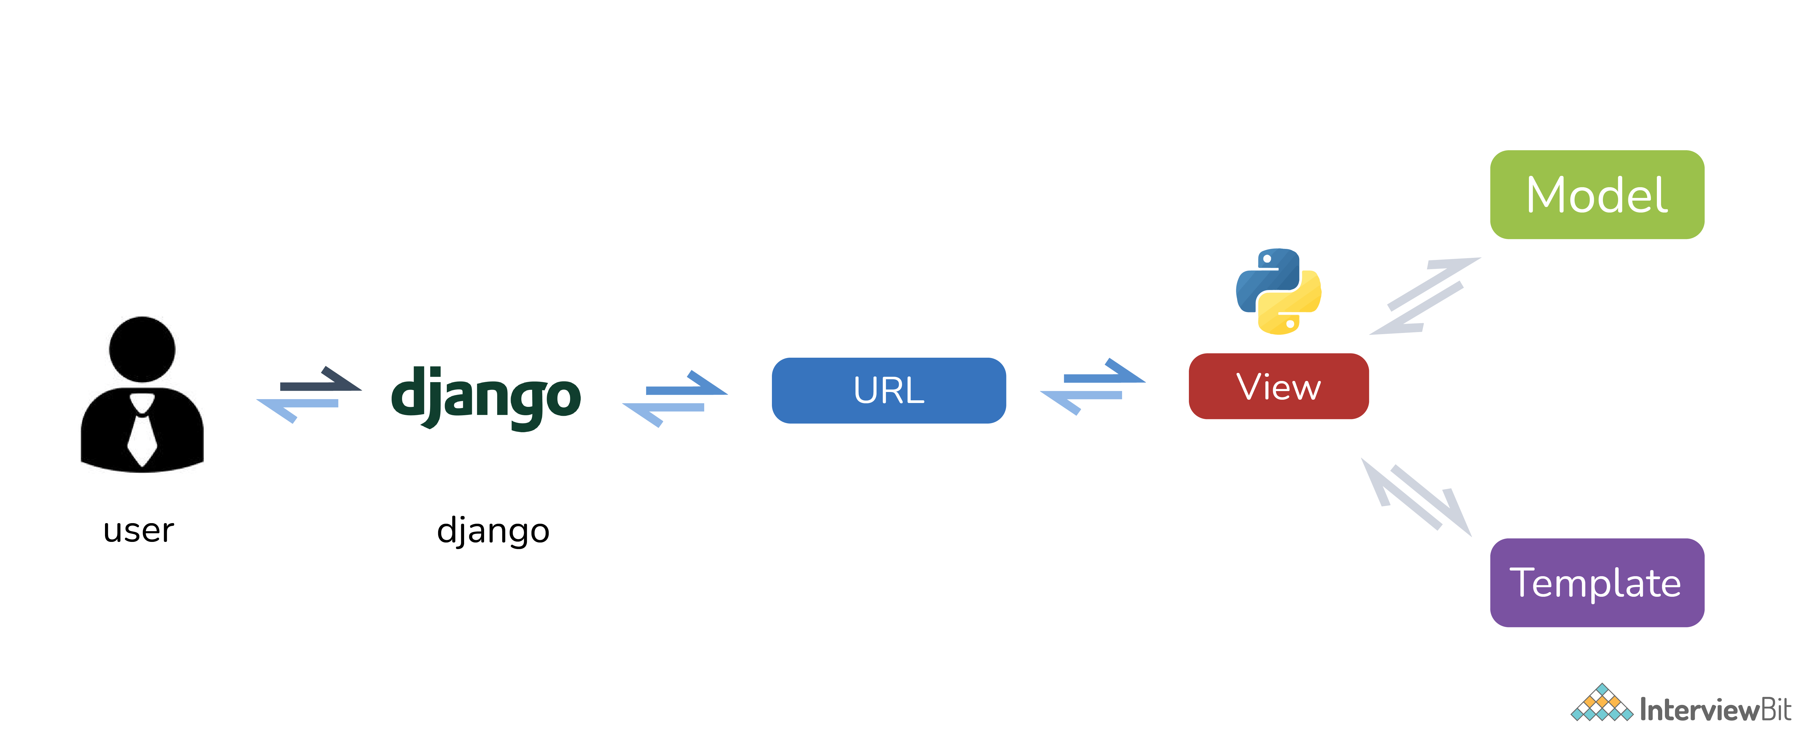

**FIG 10: S/W Architecture**

# CHAPTER 4 IMPLEMENTATION & CODING

* 1. Operating System
  2. Languages
  3. S/W Tools

## Chapter 4- IMPLEMENTATION & CODING

### OPERATING SYSTEM

* + - Windows 8/10/11
    - Mac OS: Mac OS X 10.10 or later.

### LANGUAGE

* + - **Bootstrap:** Bootstrap is a popular open-source front-end framework for building responsive and mobile-first websites and web applications. It was developed by Twitter and is currently maintained by a team of developers and contributors.
    - **SQLite:** SQLite is a lightweight, embedded, serverless relational database management system (RDBMS). It is written in the C programming language and is designed to be self-contained, meaning that it does not require a separate server process to operate. Instead, the SQLite engine is integrated into the application that uses it, making it ideal for local data storage and small-scale applications.
    - **Python**: Python is an interpreted, object-oriented, high-level programming language with dynamic semantics. It is a popular programming language. It was created by Guido Van Rossum and first released in 1991. It is known for its simplicity, readability, versatility, making it one of the most popular programming languages in the world. Some important features of python are:
      * Readability
      * Dynamic Typing
      * Interpreted
      * Cross Platform Compatibility
      * Extensive Standard Library

Various packages/frameworks of python that are used in HR51-Properties application are described below:

1. **Django**: Django is a high-level Python web framework that simplifies the process of building web applications. It follows the Model-View-Template (MVT) architectural pattern and provides a set of tools and libraries to help developers create robust and scalable web applications efficiently.
2. **Django Math Filters:** Django Math Filters is a library or package that provides a set of math-related template filters for Django web applications. It extends Django's template engine with additional mathematical operations and functions that can be applied to numeric values in your templates.

### SOFTWARE TOOLS:

* + - **PythonAnywhere**: PythonAnywhere is an online integrated development environment (IDE) and web hosting platform for python applications. It allows developers to write, run and deploy the python code directly from a web browser without the need of local installation or setup. It offers free as well as paid plans which can be purchased by the developers as per their needs and requirements. The free plan provides limited resources and features while the paid plans offer more resources, increased scalability and additional features. It is particularly used for beginners, or developers who want to host their python code without any complex setup or hosting infrastructures. It simplifies the process of coding, testing and deploying, all at the same platform. It provides various options after deployment as well such as error logs, server logs, and access logs.
    - **VS Code**: Visual Studio code is a free and open source code editor developed by Microsoft. It is widely used by developers for various programming languages and platforms, including web development, mobile app development, and cloud-based development. It’s flexibility, wide variety of extensions for formatting code, generating boiler plates, etc and continuous improvement through community contributions are the reasons for its popularity and wide usage by the users of all kinds.

### CODE SCREENSHOTS :

### Home Page:-

### Home Page Of HR51 Property which is the landing or main page of the site.

### This is the page that is visible to customers on the time of visit to our website before signup or login.

### Here is the nav bar that contains:-

### Home

### Properties

### Contact

### About

### Login

### Code:

### 

### 

### 

### Properties:-

### The Properties Section has all the properties that are listed over the site by different builders over the city.

### The Property has:-

### Builder’s Name

### Property’s Price

### Address of the Property

### Details of Property

### Here a customer can also use the filters for searching the properties as per their convenience. Filtering can be applied on any particular keyword.

### Code:

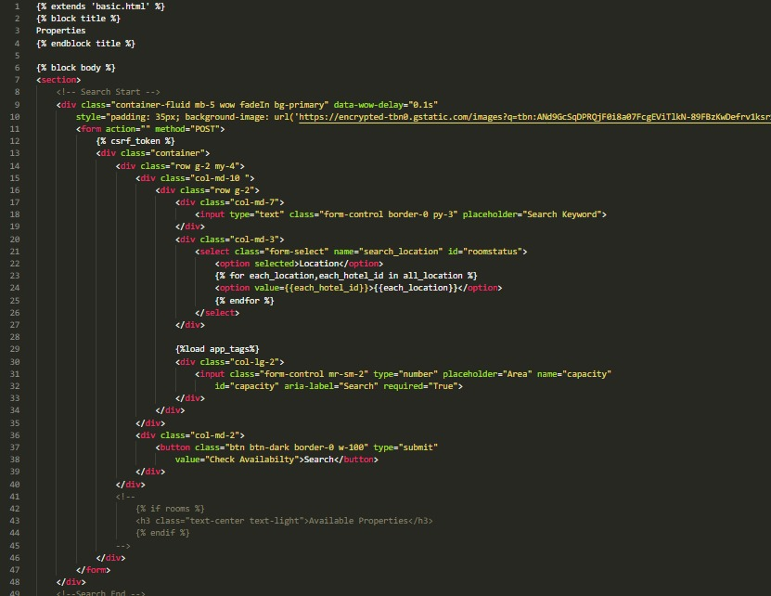

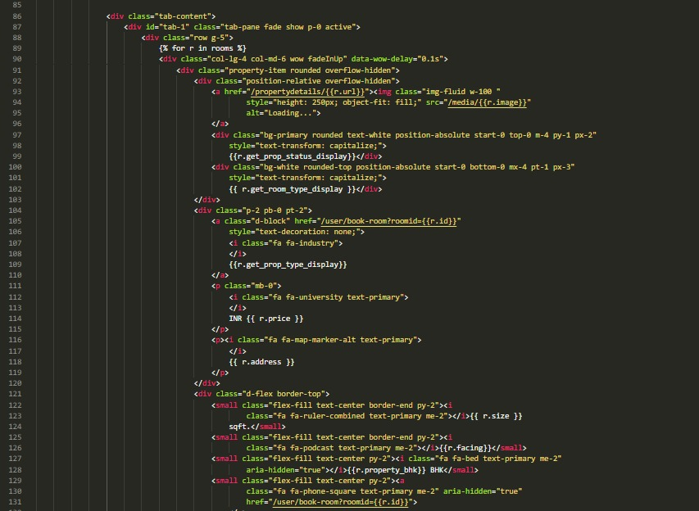

### LogIn/SignUp:-

* ‘Login’ is Common for both normal user and staff members. Staff members can enter their details a normal user but their credentials acts like a key to staff portal whereas a normal user can only be able to login into the site and can see the home page of the HR51 Property.
* ‘SignUp’ functionality is only available for customers but not for staff members because of safety issues. The Staff login credentials are only generated by Admin.

### Code:

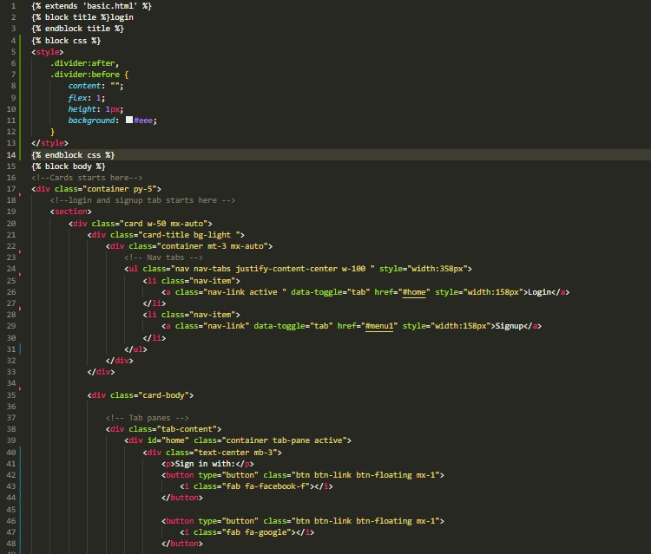

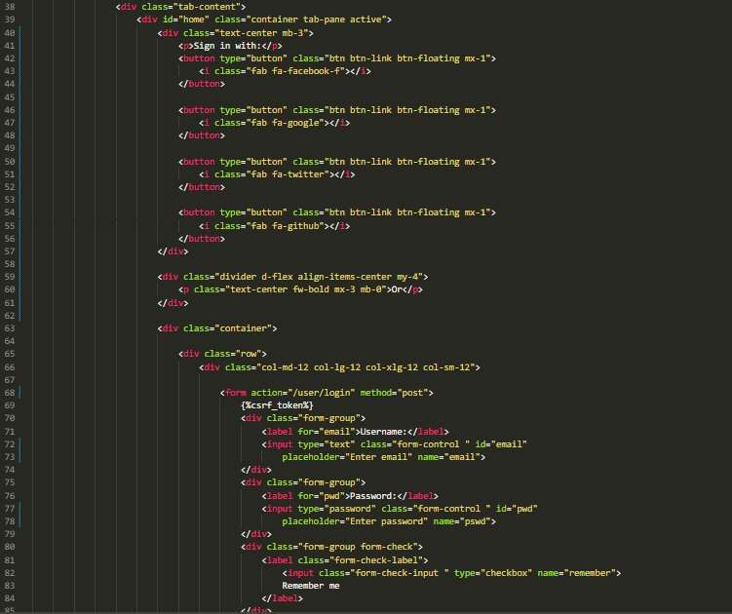

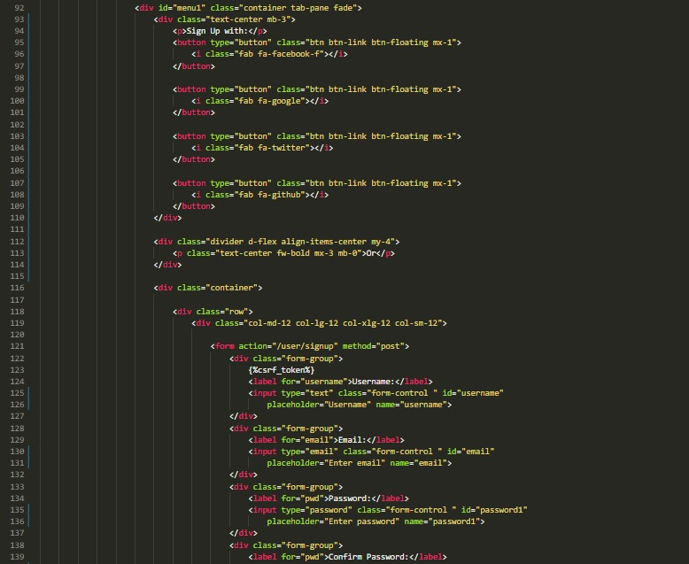

* + 1. **My Bookings:-**
* This Section shows the properties that a user has booked throughout the site. All the bookings are listed chronologically and a user can see any of that booking and it’s details.
* Some of the details will be mentioned here :-
* Name
* Property Code and Name
* Location
* Price
* Property Agent
* More Details Regarding the Property.

**Code:**

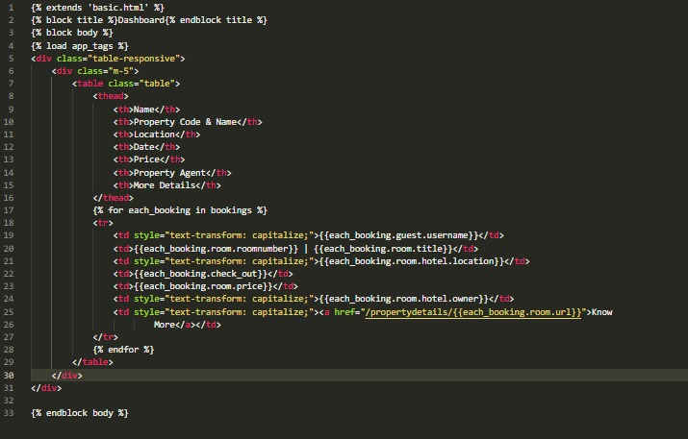

* + 1. **Property Details :-**

Property detail page provides comprehensive information about a specific property that is listed for sale or rent. The purpose of this page is to offer potential buyers or renters detailed insights into the property's features, specifications, and other relevant details. Here are some common elements found on a property detail page:

* + Property Overview: This section provides a brief summary of the property, including its type (house, apartment, etc.), location, and general features.
  + Description: A detailed description of the property, highlighting its unique selling points, architectural style, layout, and any recent renovations or upgrades.

**Code:**

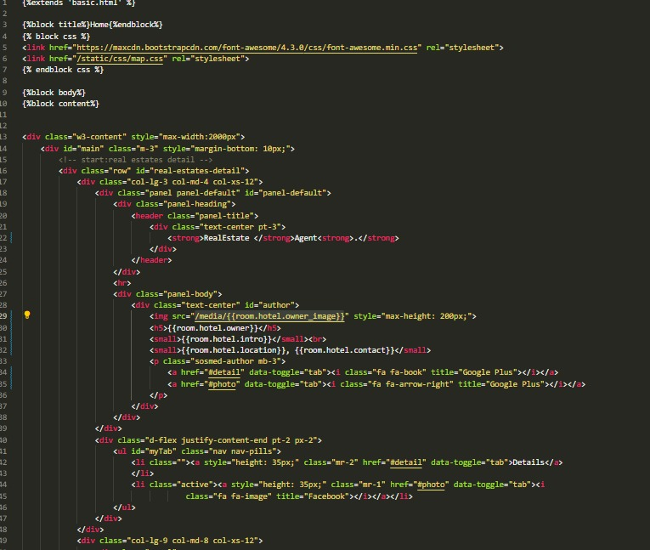

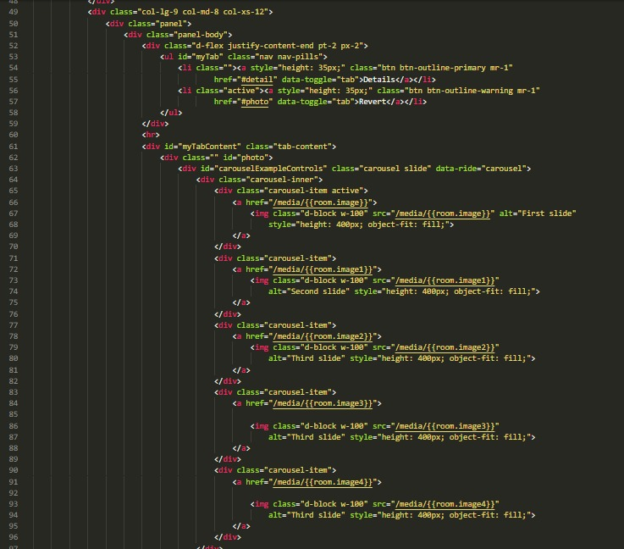

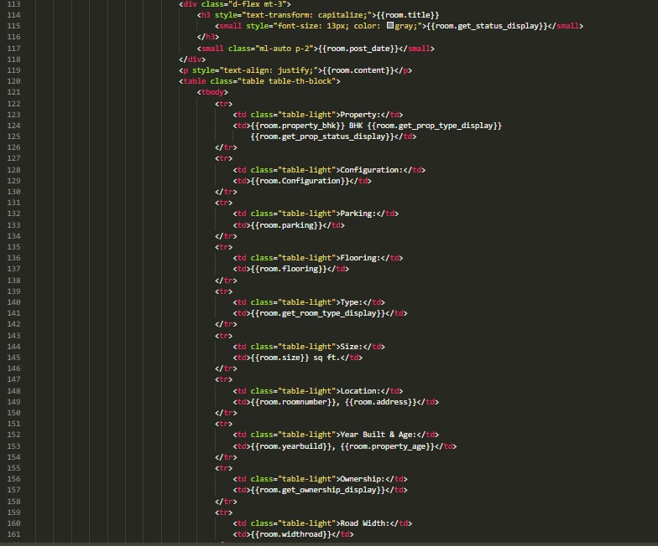

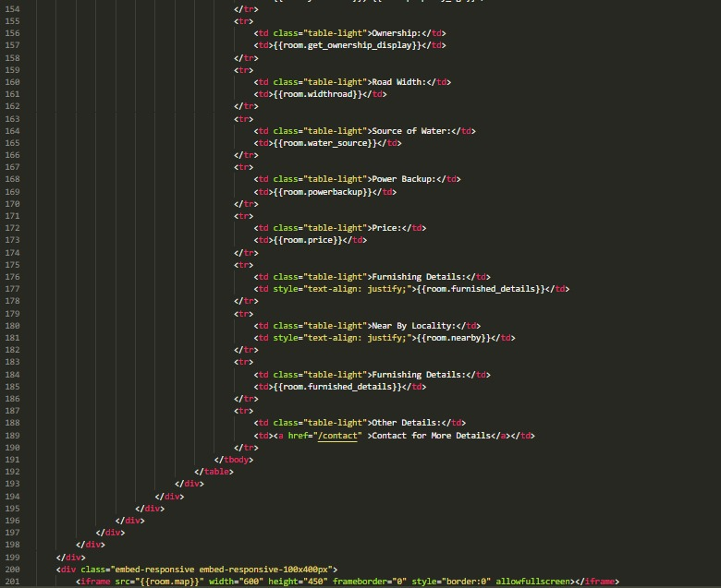

1. **Terms & Condition:-**

Terms and conditions, also known as terms of service or terms of use, are a set of rules, guidelines, and contractual obligations that users must agree to when accessing or using a website, application, or service. These terms establish the legal relationship between the user and the provider of the service or platform.

**Code:**

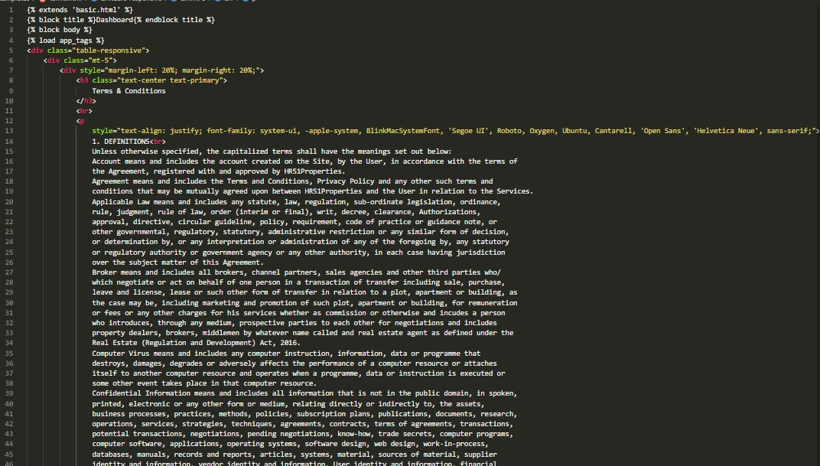

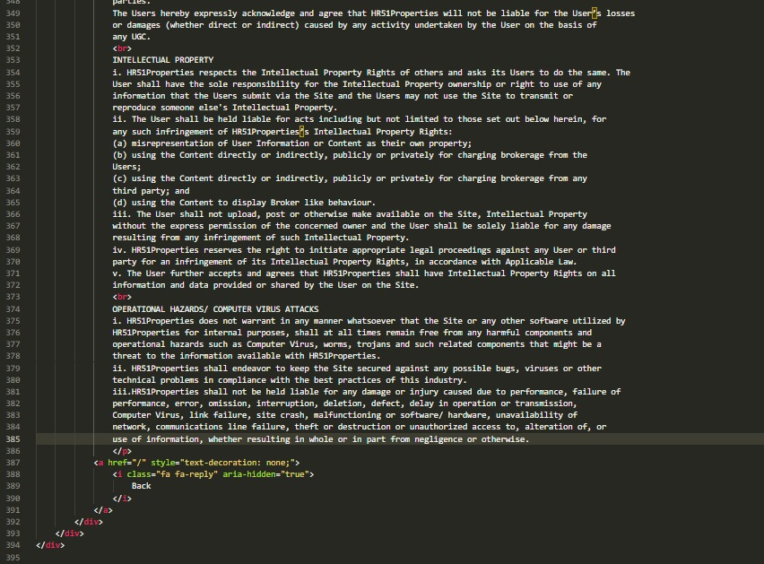

1. **Contact Us:-**

The Contact Us page provides visitors with a means to get in touch with the website owner or customer support team. It typically includes information and various communication channels that allow users to reach out for inquiries, feedback, or assistance. The Contact Us page serves as a bridge between the website and its users, facilitating effective communication and engagement.

**Code:**

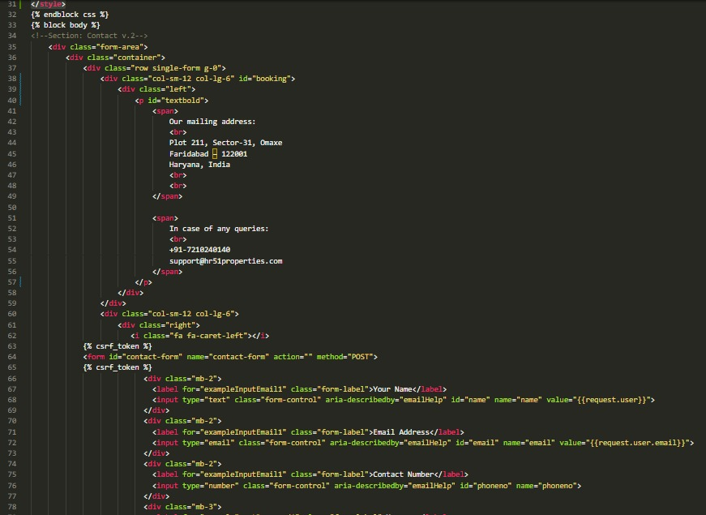

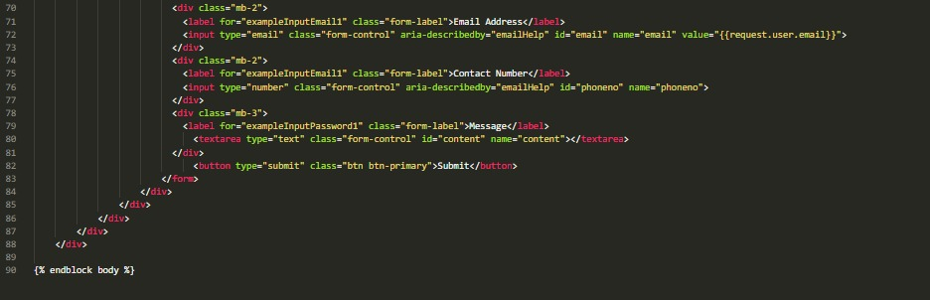

1. **Review Page:-**

where we provide honest and insightful feedback on a wide range of products/services. Our team of experts meticulously evaluates each offering to help you make informed decisions. Discover unbiased reviews, ratings, and detailed analyses that highlight the pros and cons of various options.

**Code:**

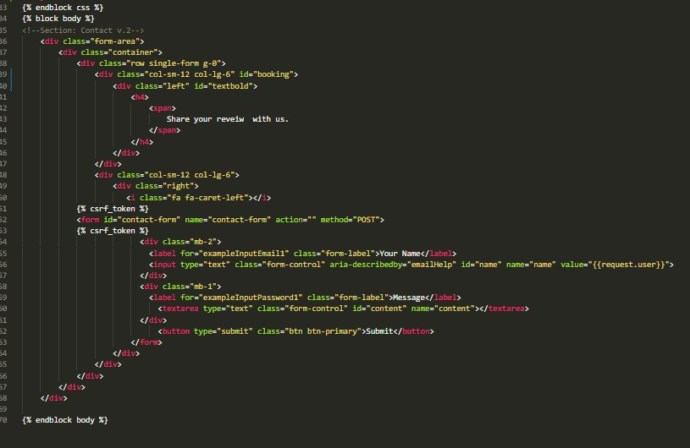

1. **User Profile:-**

Email: The email address associated with a user's account. It is used for communication, account verification, and password recovery purposes. The email should be unique and private to the user.

Username: A username is a unique identifier chosen by a user to represent themselves on a particular platform or website. It is often displayed publicly and used for login purposes. Usernames can be chosen based on personal preference, and they may or may not reflect the user's real name. They are often used in social media, online forums, and other online communities.

**Code:**

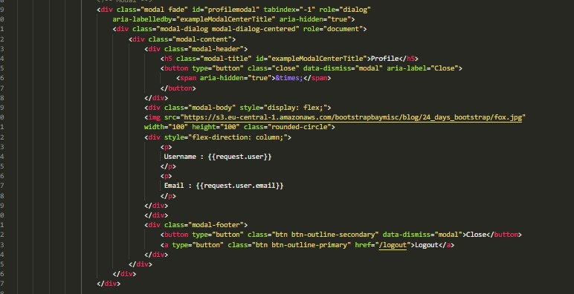

1. **Staff User:-**

Staff Userassist in property management, client interaction, and day-to-day operations of the real estate business.Staff members can manage their assigned property listings. They can add new properties, edit property details, update availability status, and view inquiries related to their listings. Staff members can schedule and manage property viewings and appointments with clients. They can coordinate appointment timings. Keeps a record of past appointments, including details such as the property viewed, the user's name, date.

**Code:**

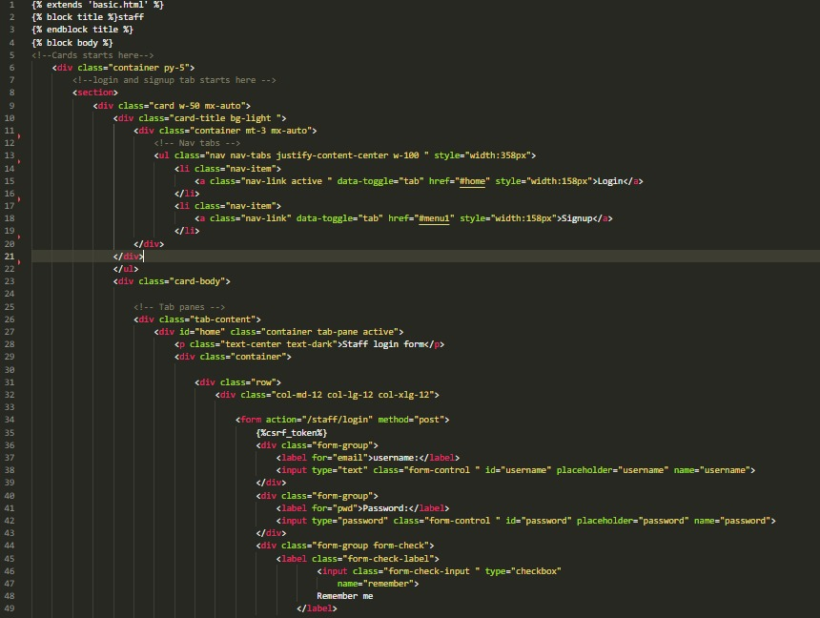

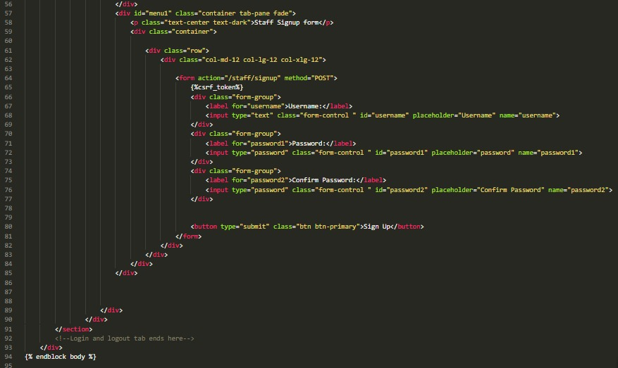

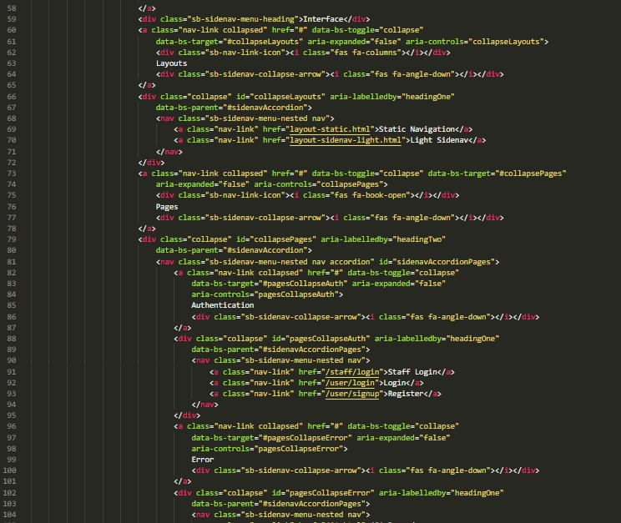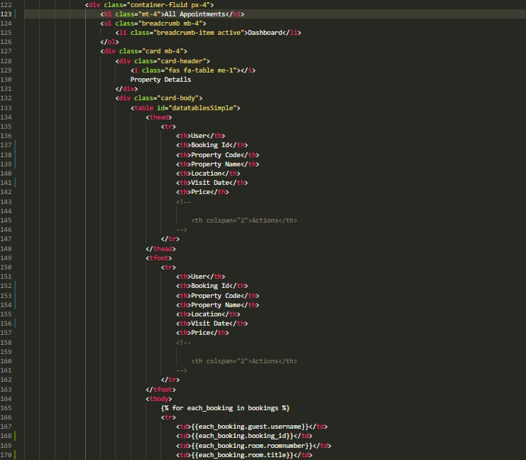

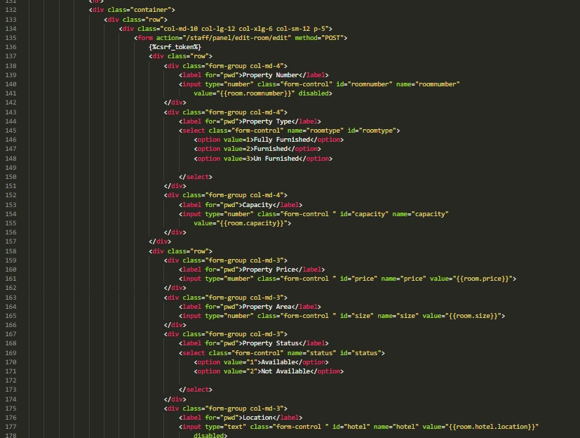

1. **Administrative:-**

The admin user has administrative privileges and controls the overall functioning of the application. The admin should have access to features such as user management, content management, and staff management. The admin user is responsible for managing user accounts, setting permissions and access levels, monitoring system etc.

**Code:**

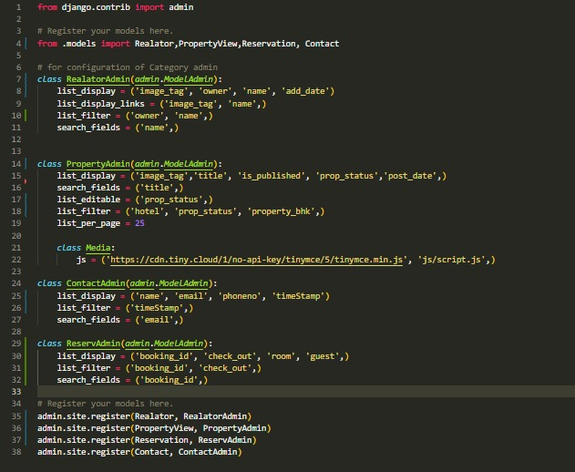

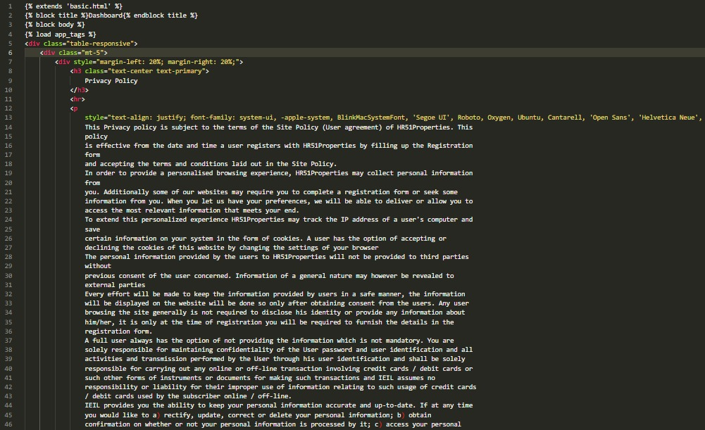

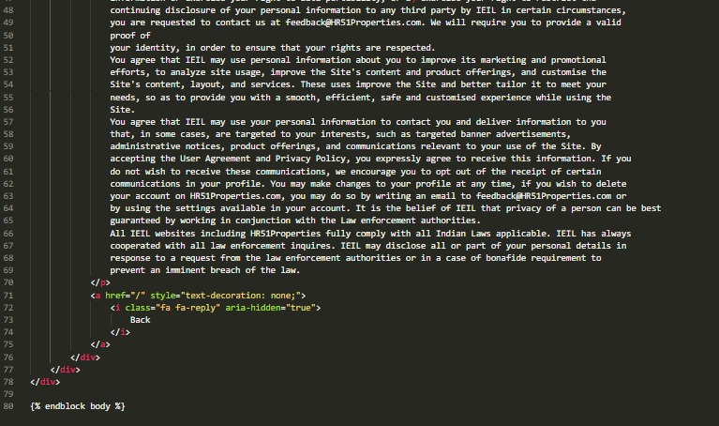

### OUTPUT SCREENSHOTS :

### Home Page:-

### Home Page Of HR51 Property which is the landing or main page of the site.

### This is the page that is visible to customers on the time of visit to our website before signup or login.

### Here is the nav bar that contains:-

### Home

### Properties

### Contact

### About

### Login

### Output:

### 

### Properties:-

### The Properties Section has all the properties that are listed over the site by different builders over the city.

### The Property has:-

### Builder’s Name

### Property’s Price

### Address of the Property

### Details of Property

### Here a customer can also use the filters for searching the properties as per their convenience. Filtering can be applied on any particular keyword.

**Output:**

### 

### 

### LogIn/SignUp:-

* ‘Login’ is Common for both normal user and staff members. Staff members can enter their details a normal user but their credentials acts like a key to staff portal whereas a normal user can only be able to login into the site and can see the home page of the HR51 Property.
* ‘SignUp’ functionality is only available for customers but not for staff members because of safety issues. The Staff login credentials are only generated by Admin.

### Output:

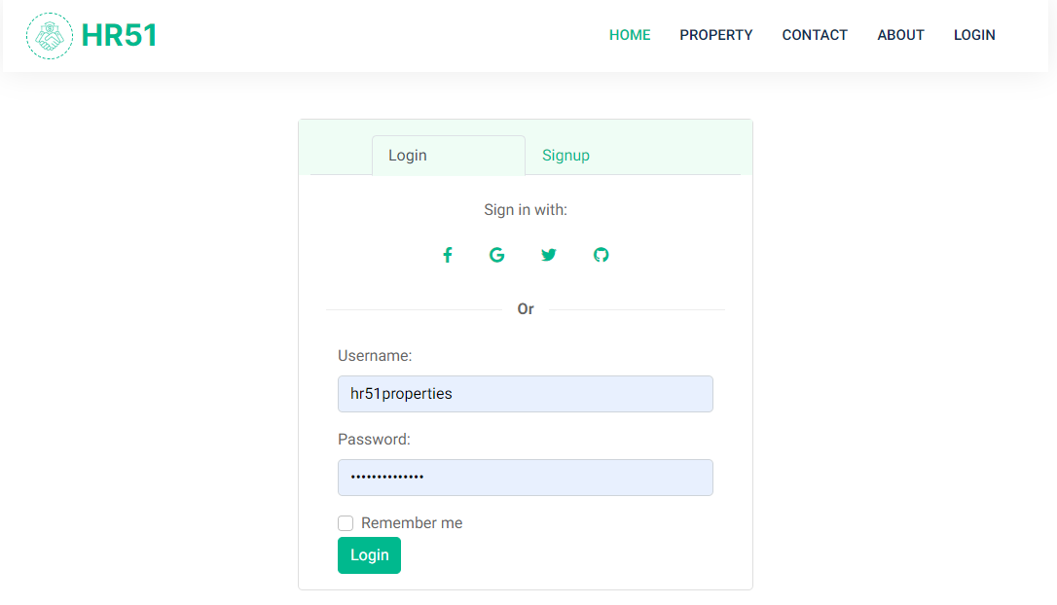

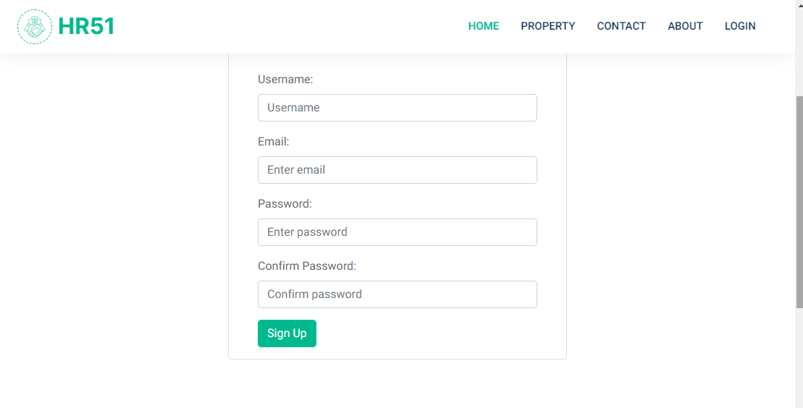

1. **My Bookings:-**

* This Section shows the properties that a user has booked throughout the site. All the bookings are listed chronologically and a user can see any of that booking and it’s details.
* Some of the details will be mentioned here :-
* Name
* Property Code and Name
* Location
* Price
* Property Agent
* More Details Regarding the Property.

**Output:**

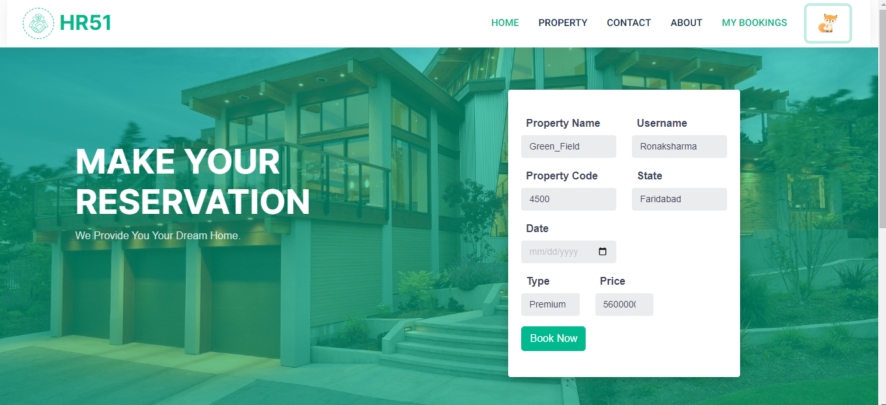

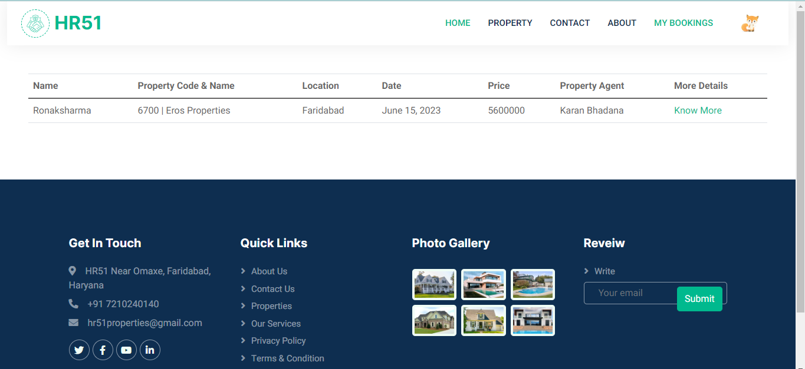

1. **Property Details :-**

Property detail page provides comprehensive information about a specific property that is listed for sale or rent. The purpose of this page is to offer potential buyers or renters detailed insights into the property's features, specifications, and other relevant details. Here are some common elements found on a property detail page:

**Output:**

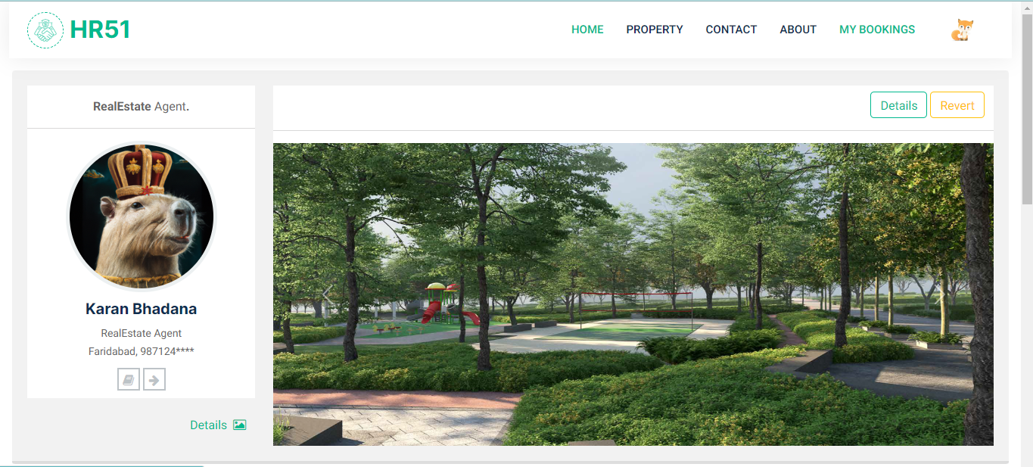

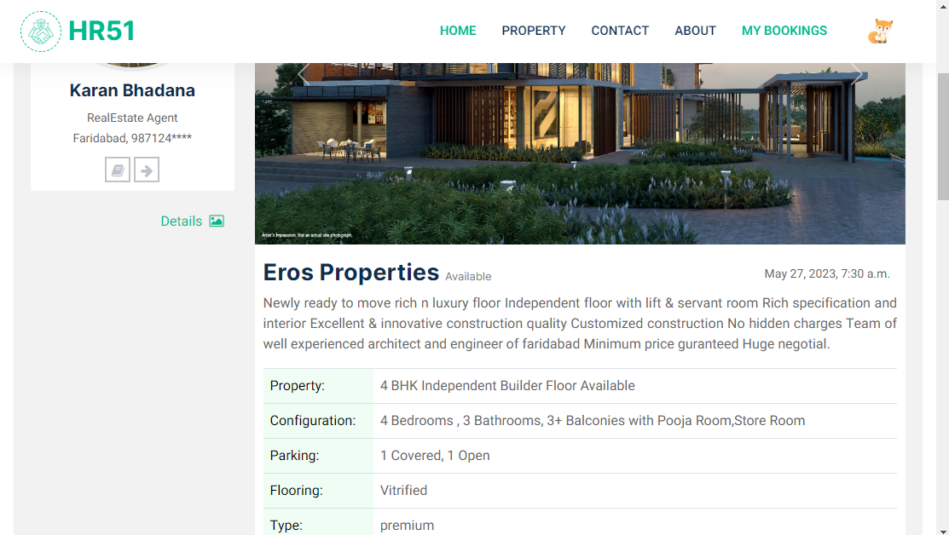

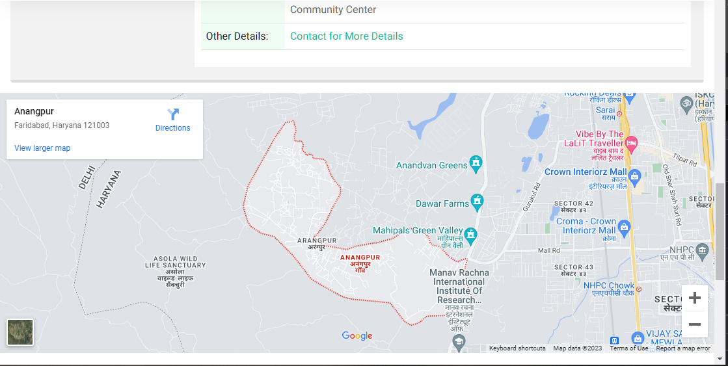

1. **Privacy & Policy:-**

A privacy policy is a legal document or statement that outlines how an organization or website collects, uses, shares, and protects the personal information of its users or visitors. It is an essential component of maintaining transparency and building trust with individuals whose data is collected.

**Output:**

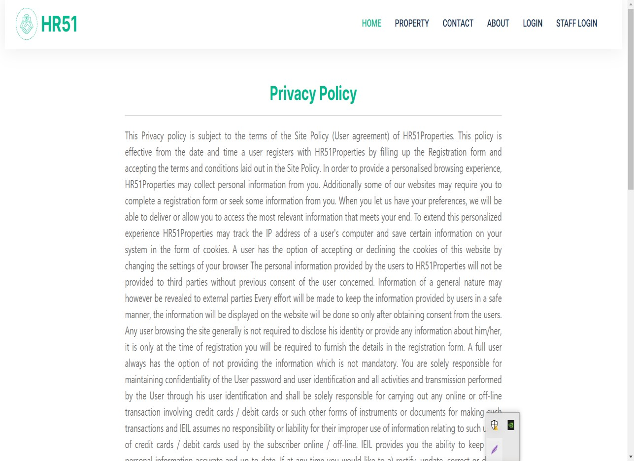

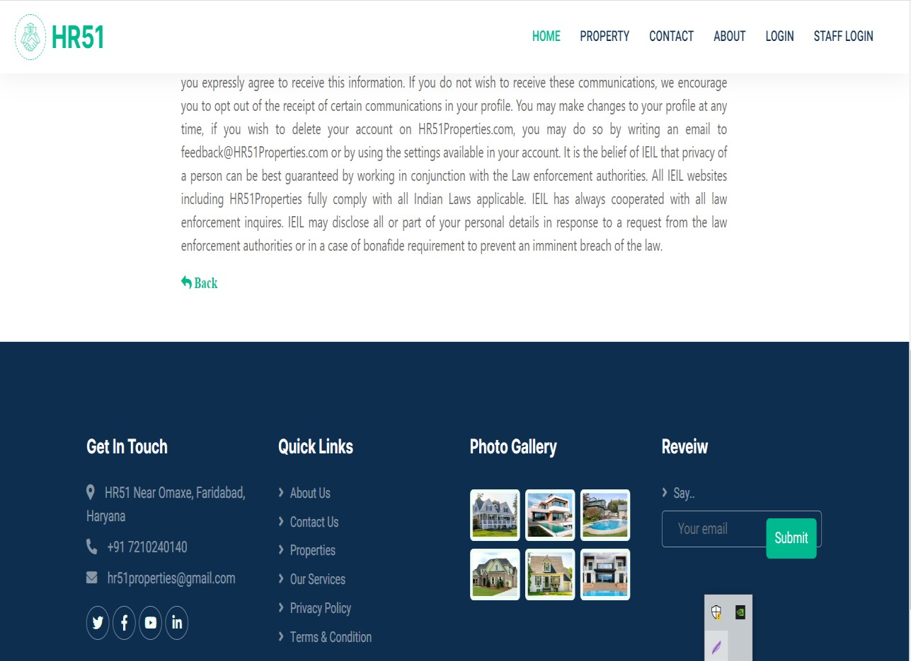

1. **Terms & Condition:-**

Terms and conditions, also known as terms of service or terms of use, are a set of rules, guidelines, and contractual obligations that users must agree to when accessing or using a website, application, or service. These terms establish the legal relationship between the user and the provider of the service or platform.

**Output:**

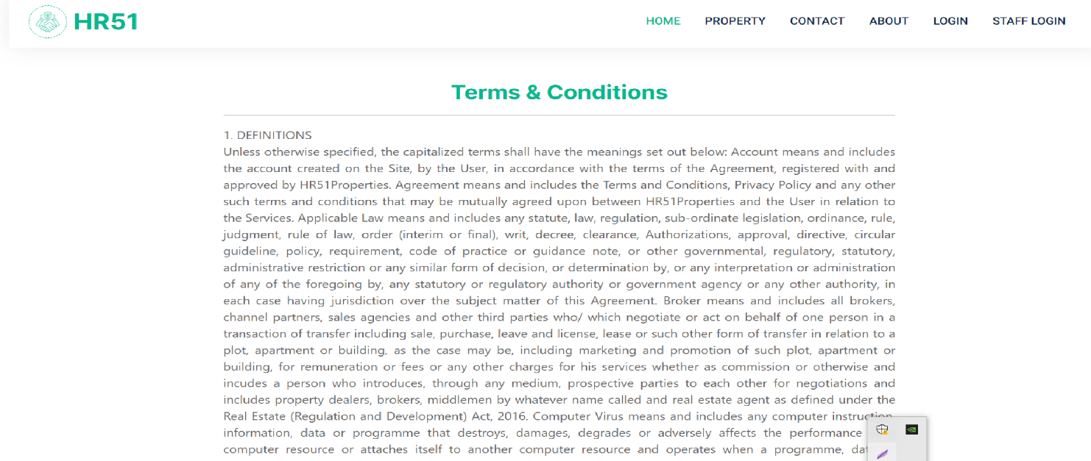

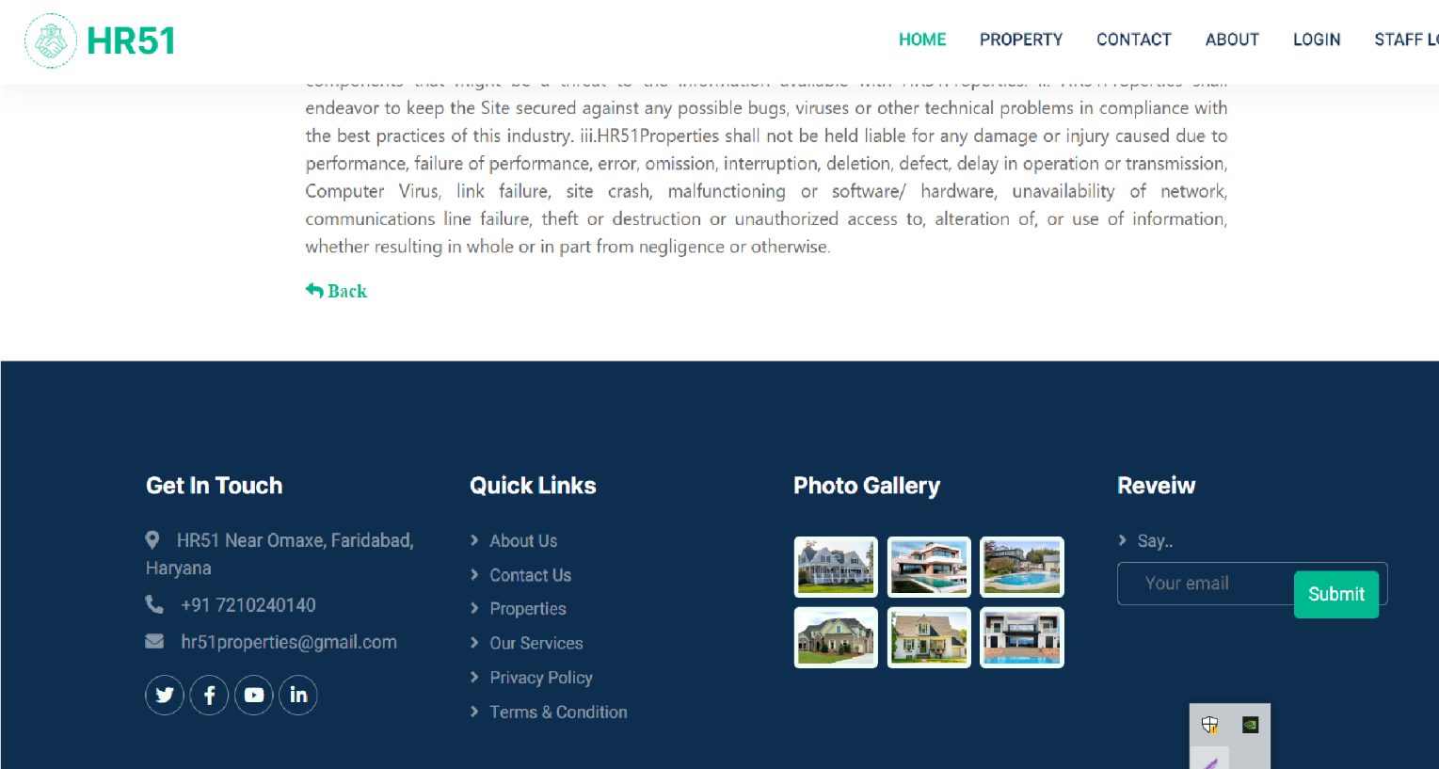

1. **Contact Us:-**

The Contact Us page provides visitors with a means to get in touch with the website owner or customer support team. It typically includes information and various communication channels that allow users to reach out for inquiries, feedback, or assistance. The Contact Us page serves as a bridge between the website and its users, facilitating effective communication and engagement.

**Output:**

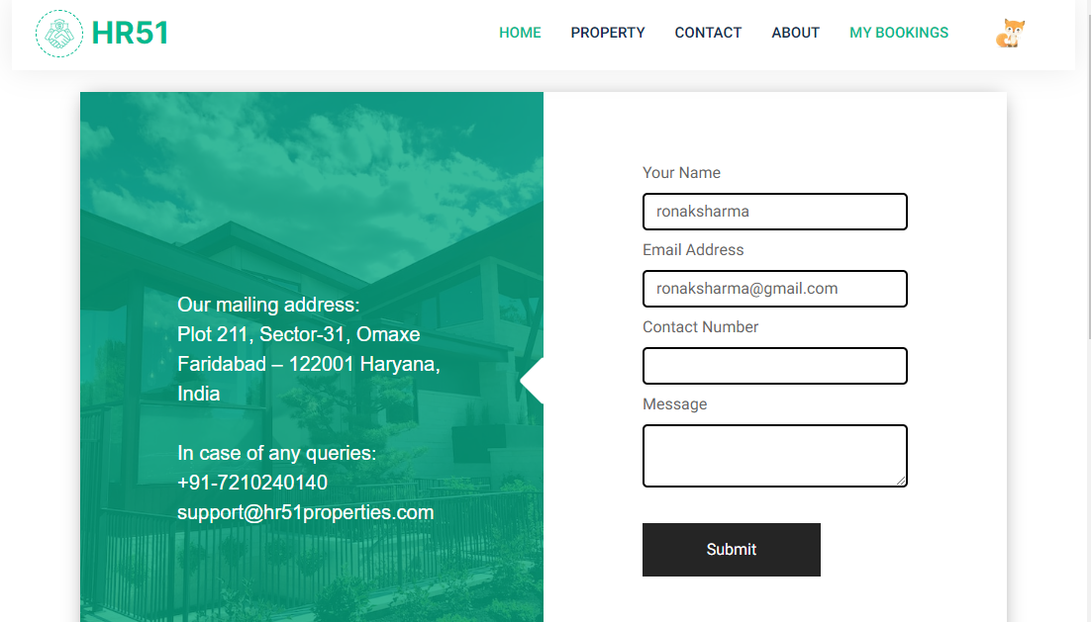

1. **Review Page:-**

where we provide honest and insightful feedback on a wide range of products/services. Our team of experts meticulously evaluates each offering to help you make informed decisions. Discover unbiased reviews, ratings, and detailed analyses that highlight the pros and cons of various options.

**Output:**

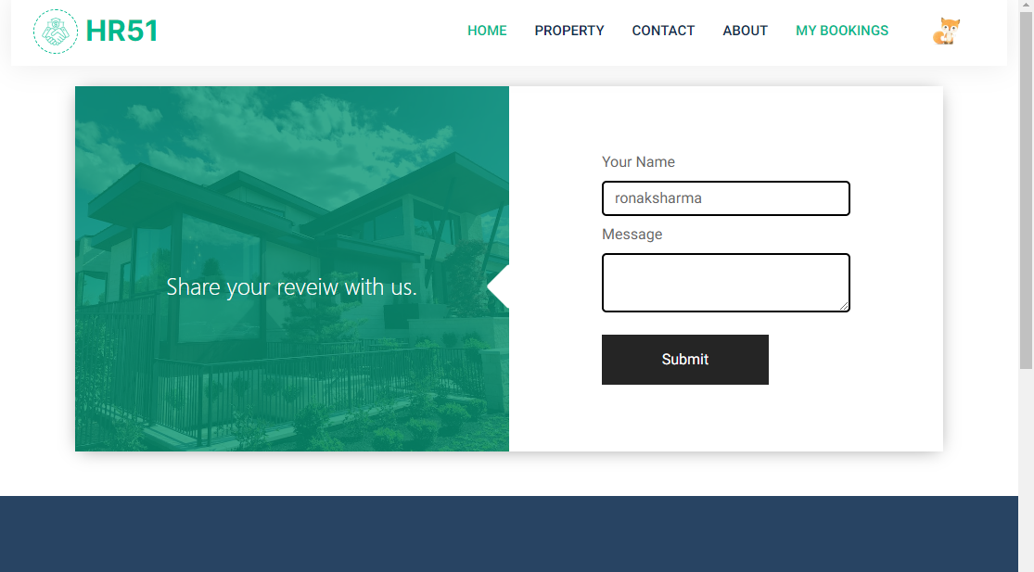

1. **User Profile:-**

Email: The email address associated with a user's account. It is used for communication, account verification, and password recovery purposes. The email should be unique and private to the user.

Username: A username is a unique identifier chosen by a user to represent themselves on a particular platform or website. It is often displayed publicly and used for login purposes. Usernames can be chosen based on personal preference, and they may or may not reflect the user's real name. They are often used in social media, online forums, and other online communities.

**Output:**

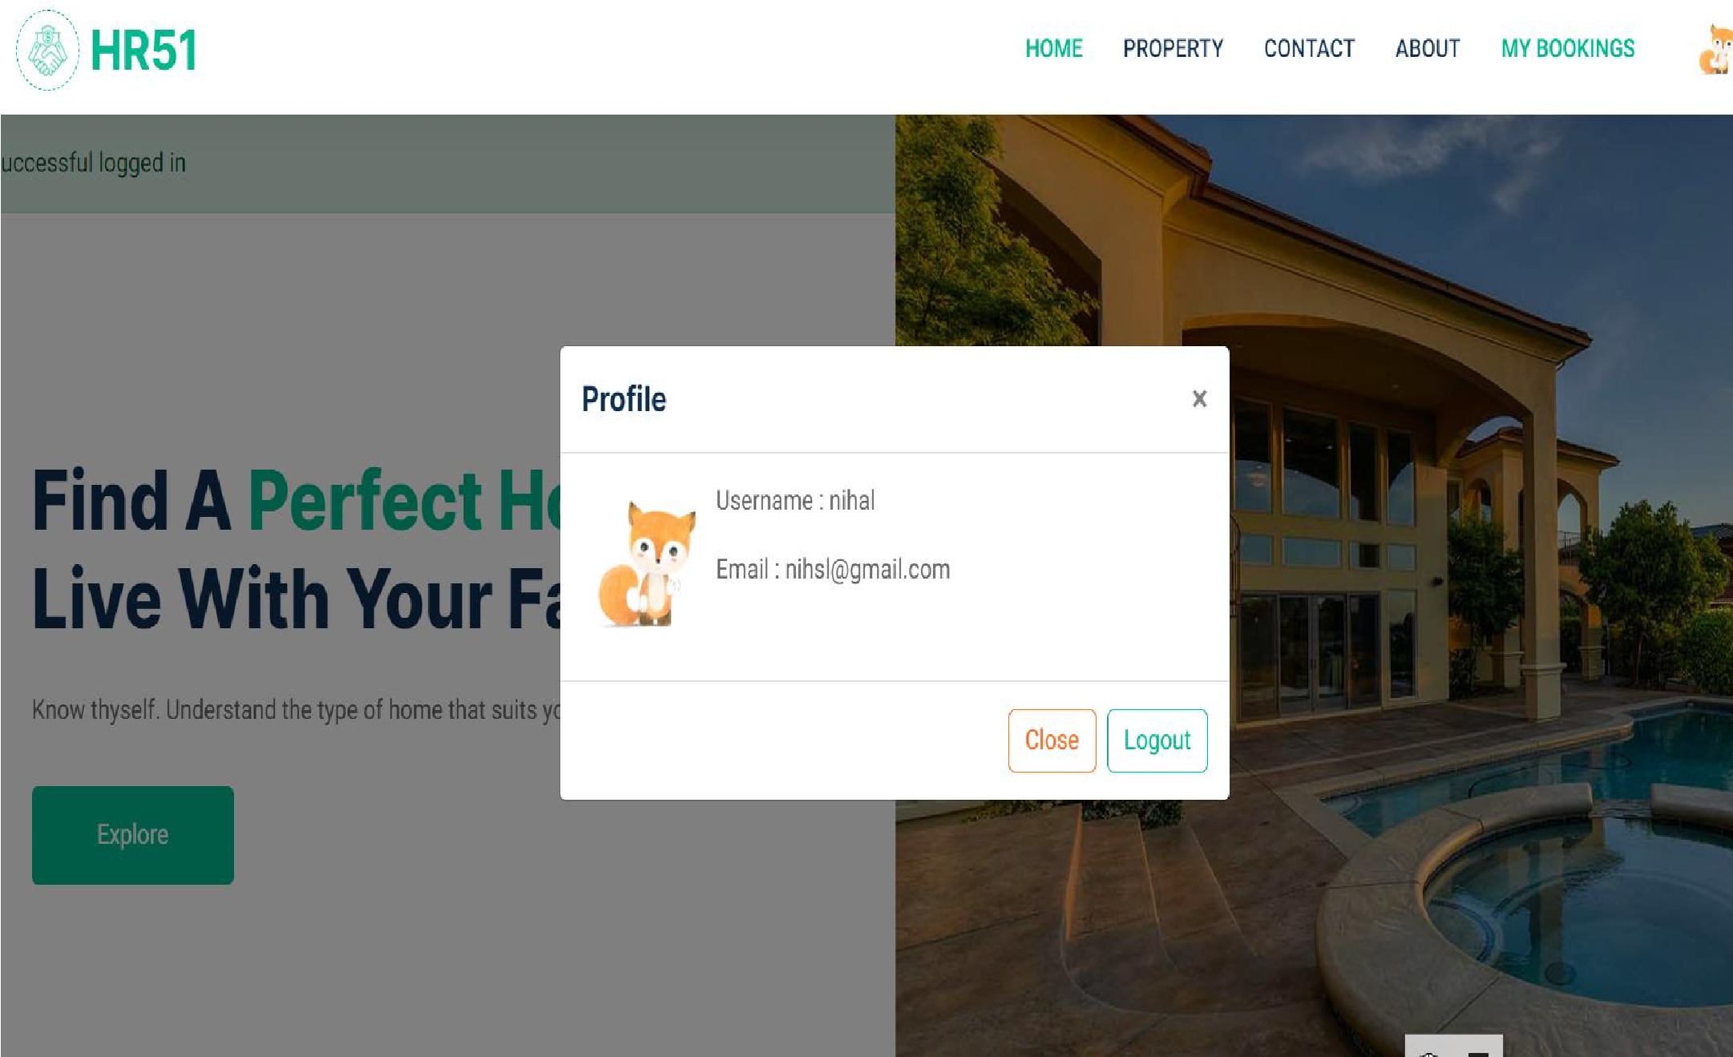

1. **Staff User:-**

Staff Userassist in property management, client interaction, and day-to-day operations of the real estate business.Staff members can manage their assigned property listings. They can add new properties, edit property details, update availability status, and view inquiries related to their listings. Staff members can schedule and manage property viewings and appointments with clients. They can coordinate appointment timings. Keeps a record of past appointments, including details such as the property viewed, the user's name, date.

**Output:**

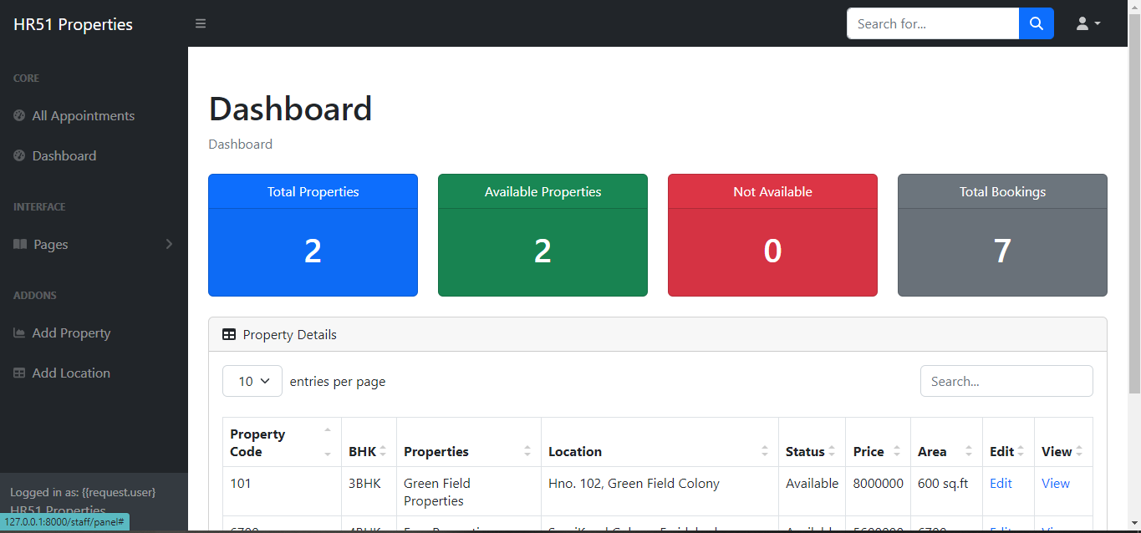

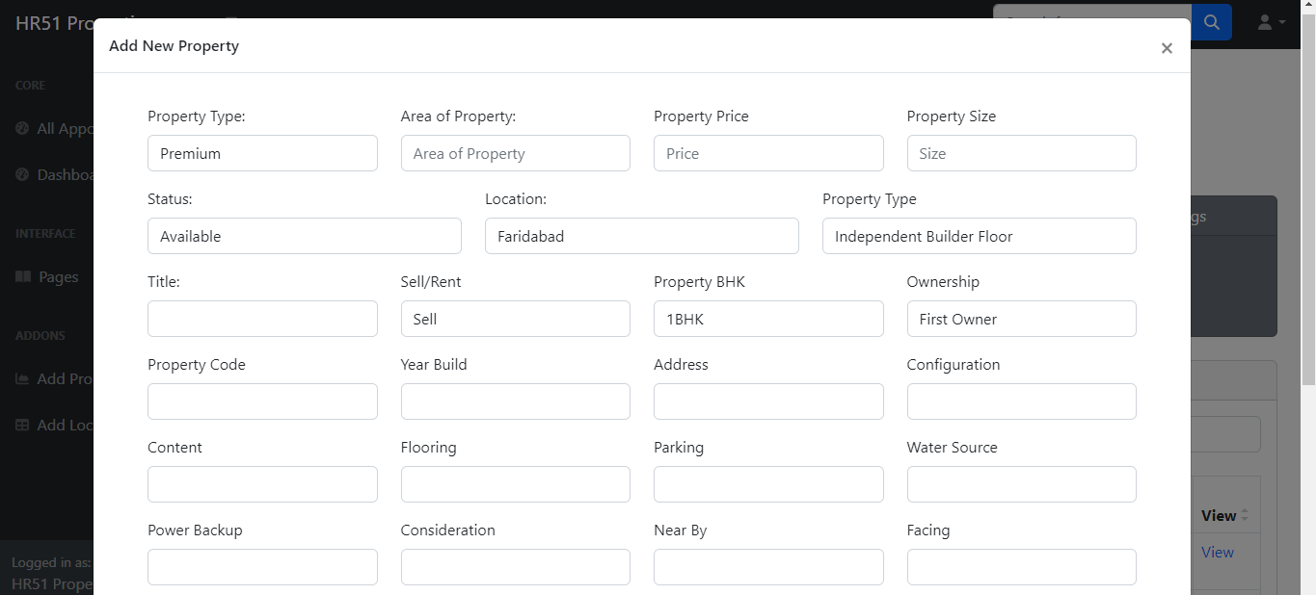

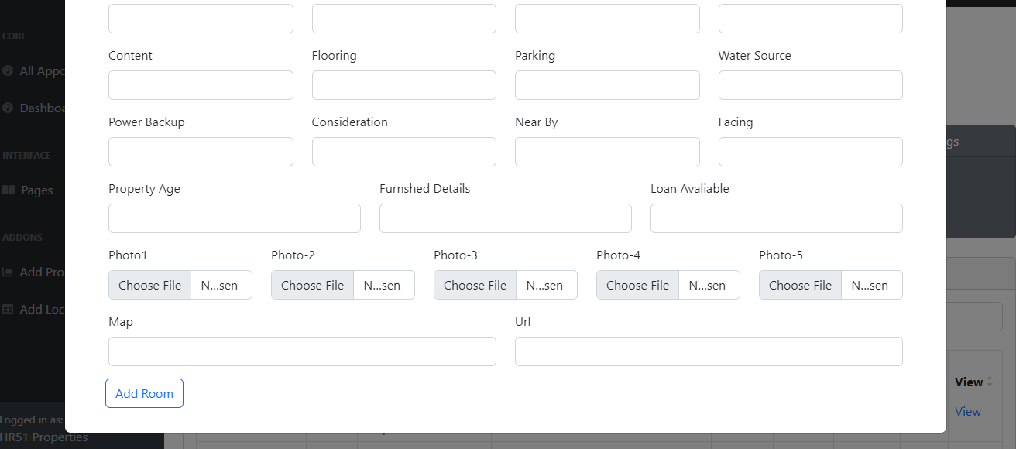

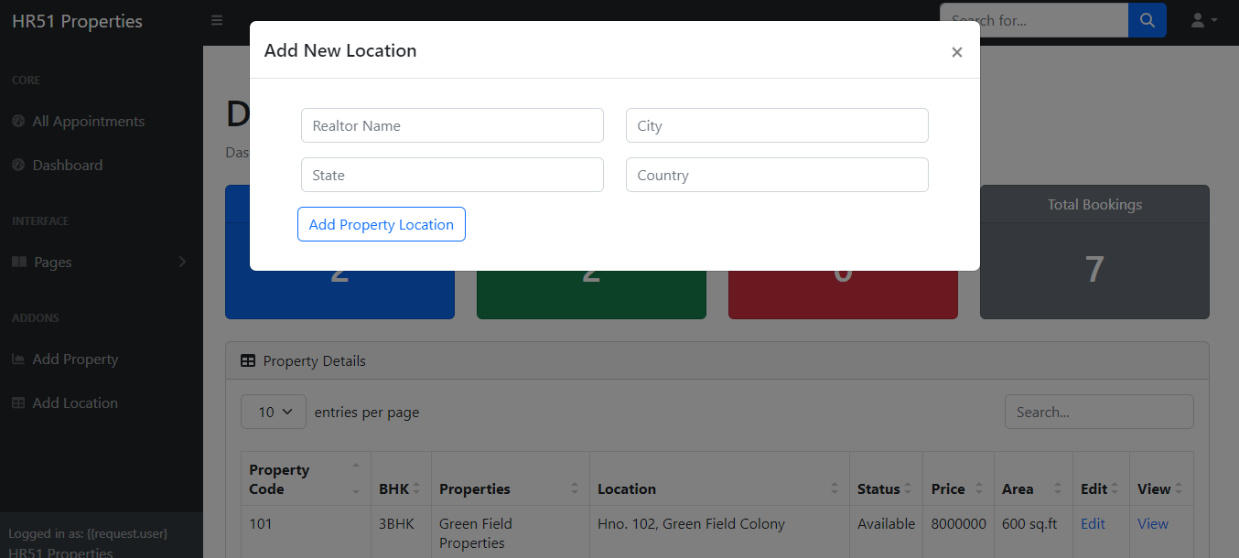

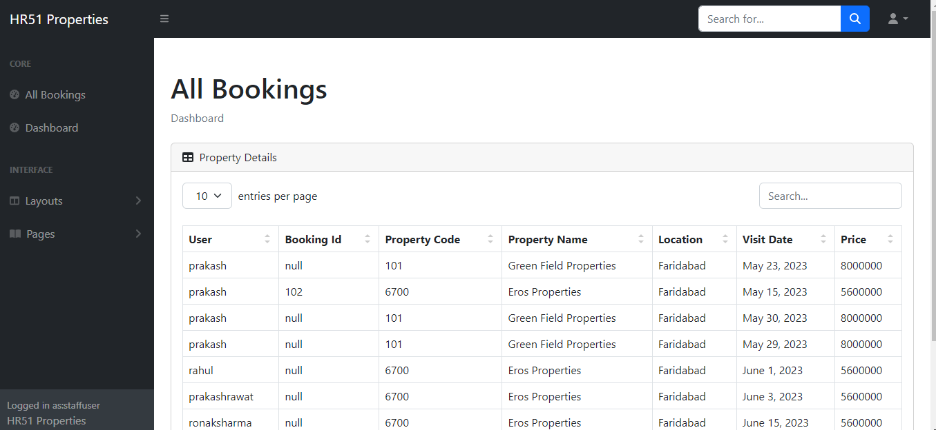

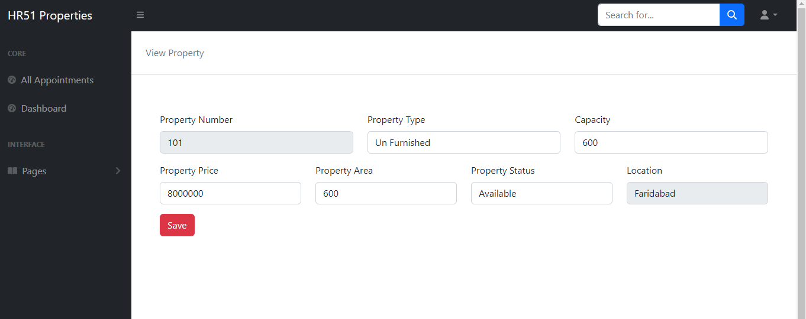

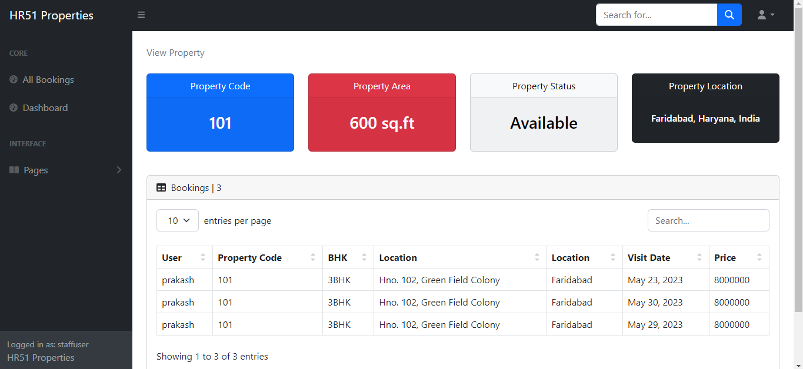

1. **Administrative:-**

The admin user has administrative privileges and controls the overall functioning of the application. The admin should have access to features such as user management, content management, and staff management. The admin user is responsible for managing user accounts, setting permissions and access levels, monitoring system etc.

**Output:**

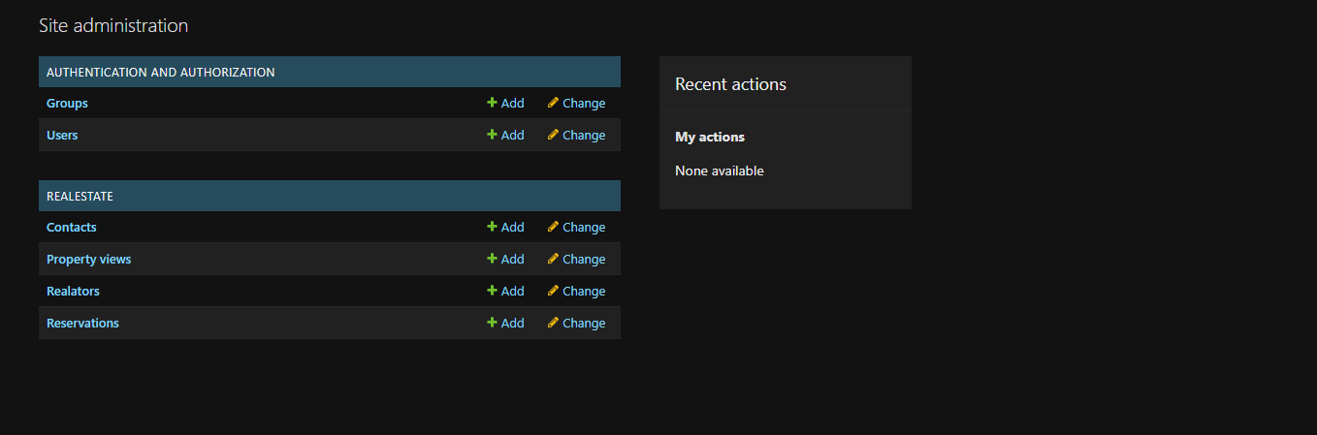

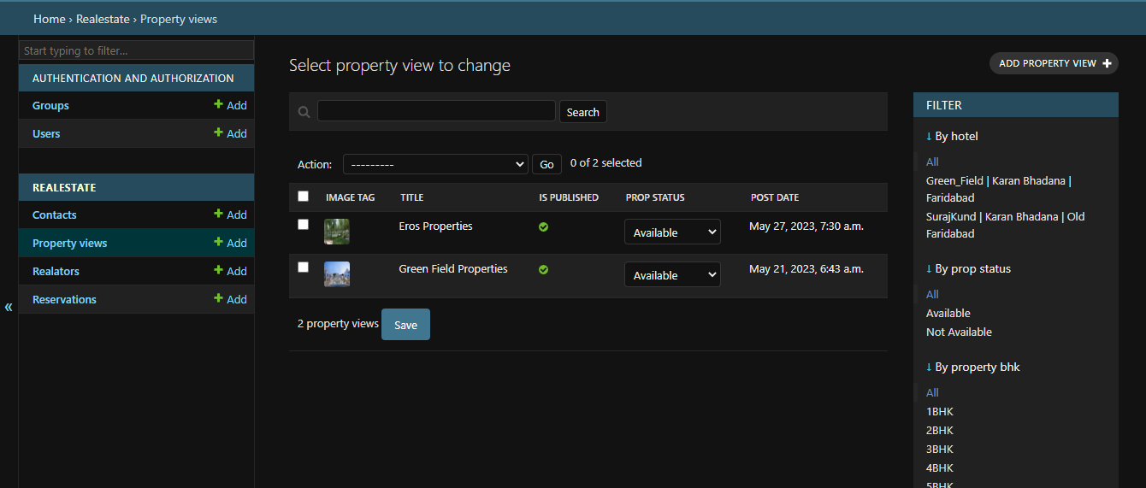

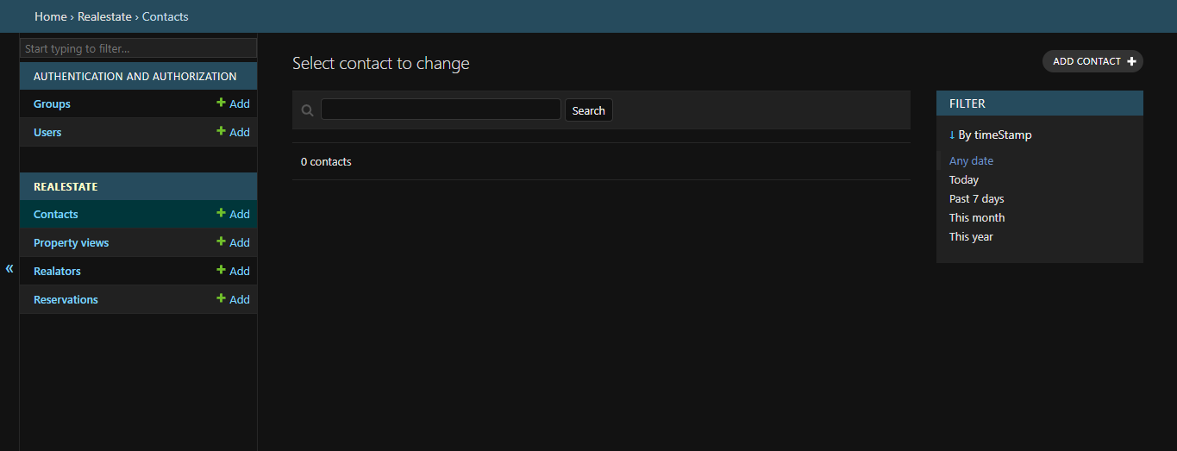

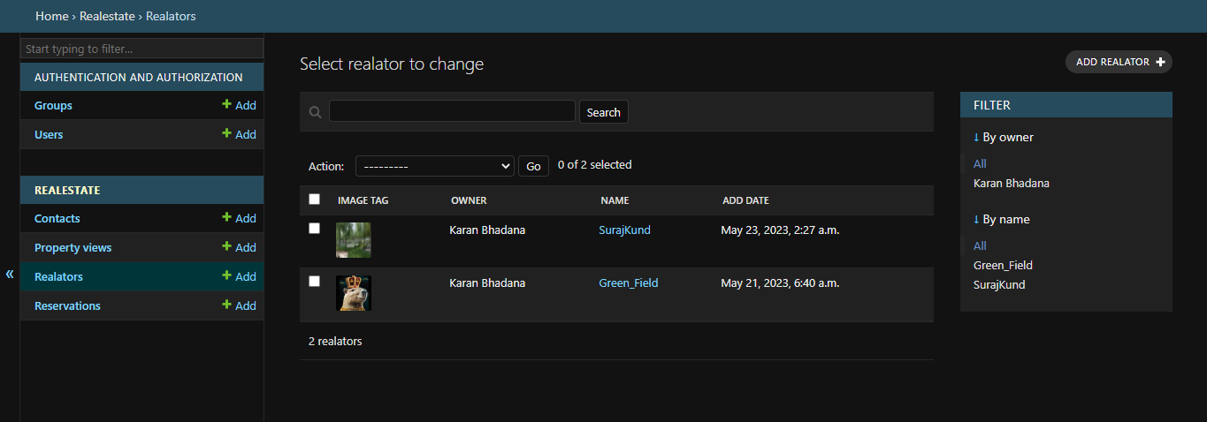

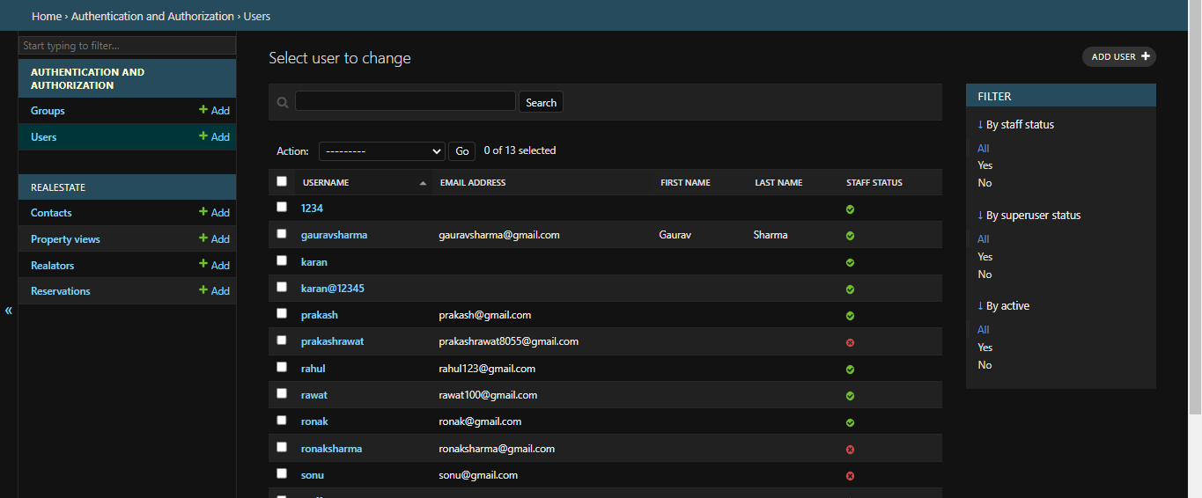

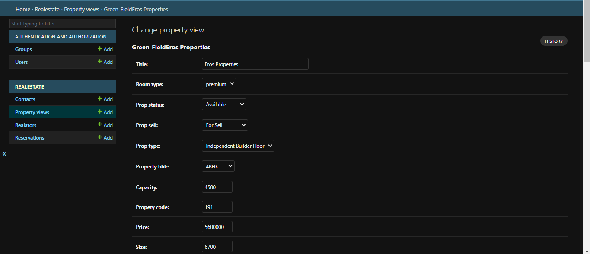

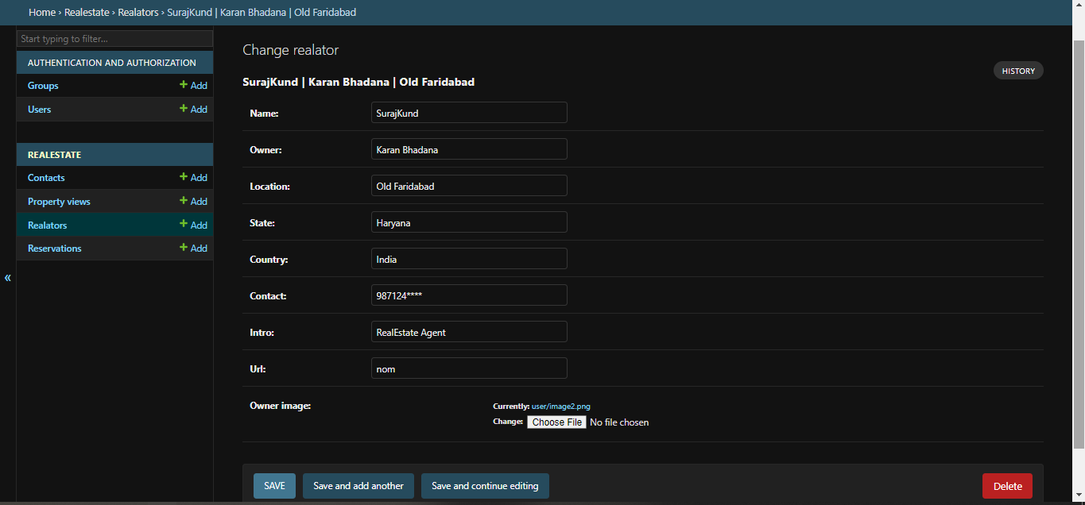

1. **Database:-**

* Django is a Python web framework that comes with built-in support for SQLite, a lightweight and serverless relational database engine. SQLite is a self-contained, file-based database that doesn't require a separate server process to operate, making it easy to use and suitable for small to medium-sized projects or development and testing environments.
* When using Django with SQLite, here are some key points to consider:

The `NAME` parameter specifies the path to the SQLite database file. By default, Django creates a file named `db.sqlite3` in the project's root directory.

* Database Creation:

To create the SQLite database file, run the following command: `python manage.py migrate`. This command will create the necessary tables and schema in the SQLite database file based on your Django models.

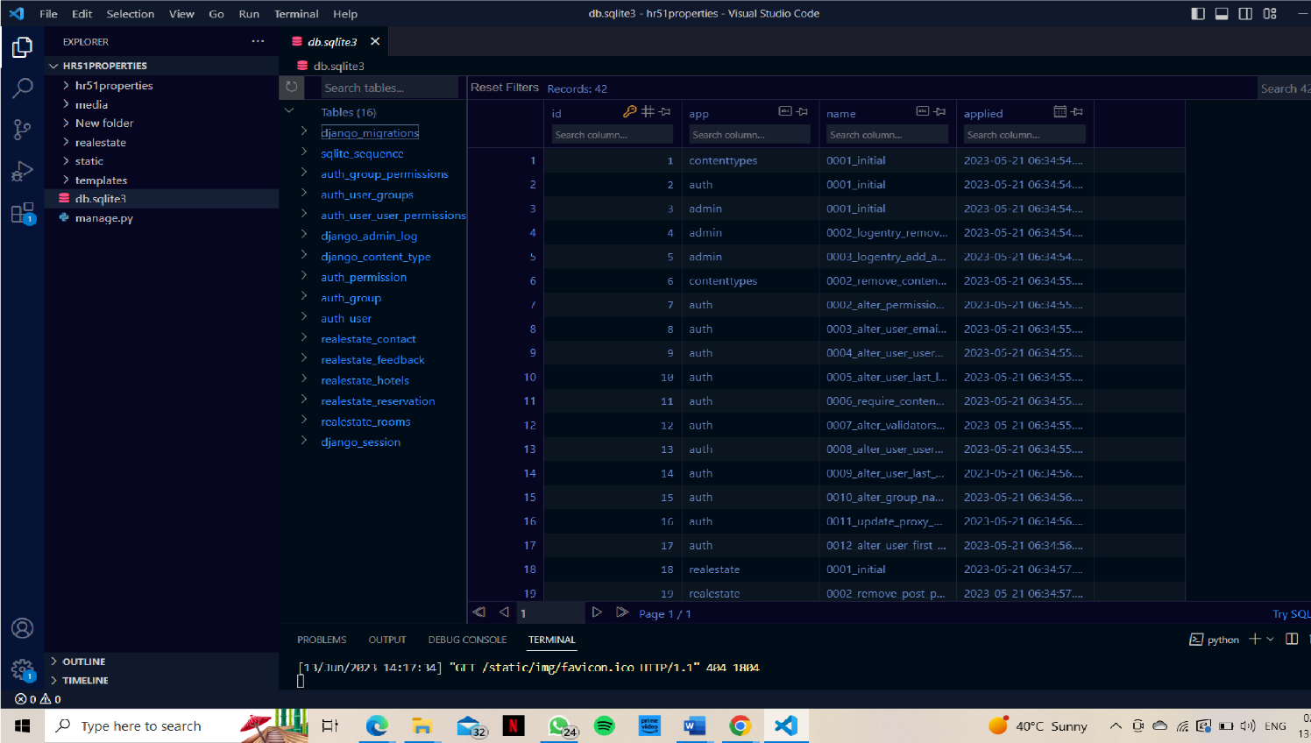

**Admin Log:**

• Start the development server:

- Run the command `python manage.py runserver` to start the Django development server.

• Access the admin site:

* Open a web browser and go to `http://localhost:8000/admin` (replace `localhost:8000` with the appropriate address if you're running the server on a different host/port).
* You should see the Django admin login page.

• Admin site dashboard:

* After successful login, you will be redirected to the Django admin site's main dashboard.
* From here, you can manage various aspects of your Django project, including database models, users, groups, permissions, and more.

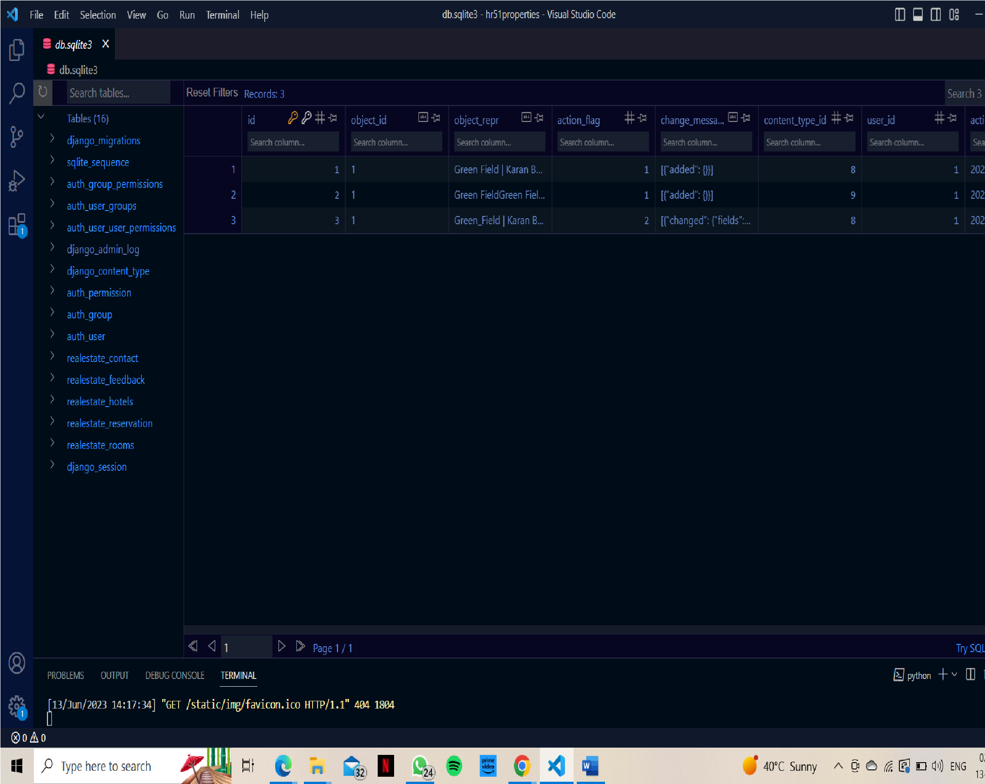

##### Auth Permission:-

In Django, permissions are a built-in feature of the authentication and authorization system. Permissions determine what actions or operations a user can perform on specific resources within a Django project. The `Permission` model and the `User` model are closely related.

* Here's an overview of how permissions work in Django:
* Permissions in Django:

Permissions are defined and managed through the `Permission` model, which is included in the `django.contrib.auth` module.

Each permission is represented by an instance of the `Permission` model, which has fields such as `name`, `content_type`, and `codename`.

* Built-in Permissions:

Django provides three default permission types: `add`, `change`, and `delete`.

These permissions correspond to the ability to create, update, and delete objects of a specific model respectively.

* Defining Custom Permissions:

You can define custom permissions for your models by creating instances of the `Permission` model and associating them with specific models.

Custom permissions can represent additional actions or operations beyond the default ones provided by Django.

* Assigning Permissions:

Permissions are assigned to users through user groups or directly to individual users.

User groups can be created using the `Group` model provided by Django, and each group can be assigned one or more permissions.

* Checking Permissions:

To check if a user has a specific permission, you can use the `has_perm()` method provided by the `User` model.

* Authorization and Views:

Django provides various ways to handle authorization and permissions in views.

You can use decorators like `@login_required` to restrict access to certain views only to authenticated users.

Additionally, you can use the `@permission_required` decorator to further restrict access to views based on specific permissions.

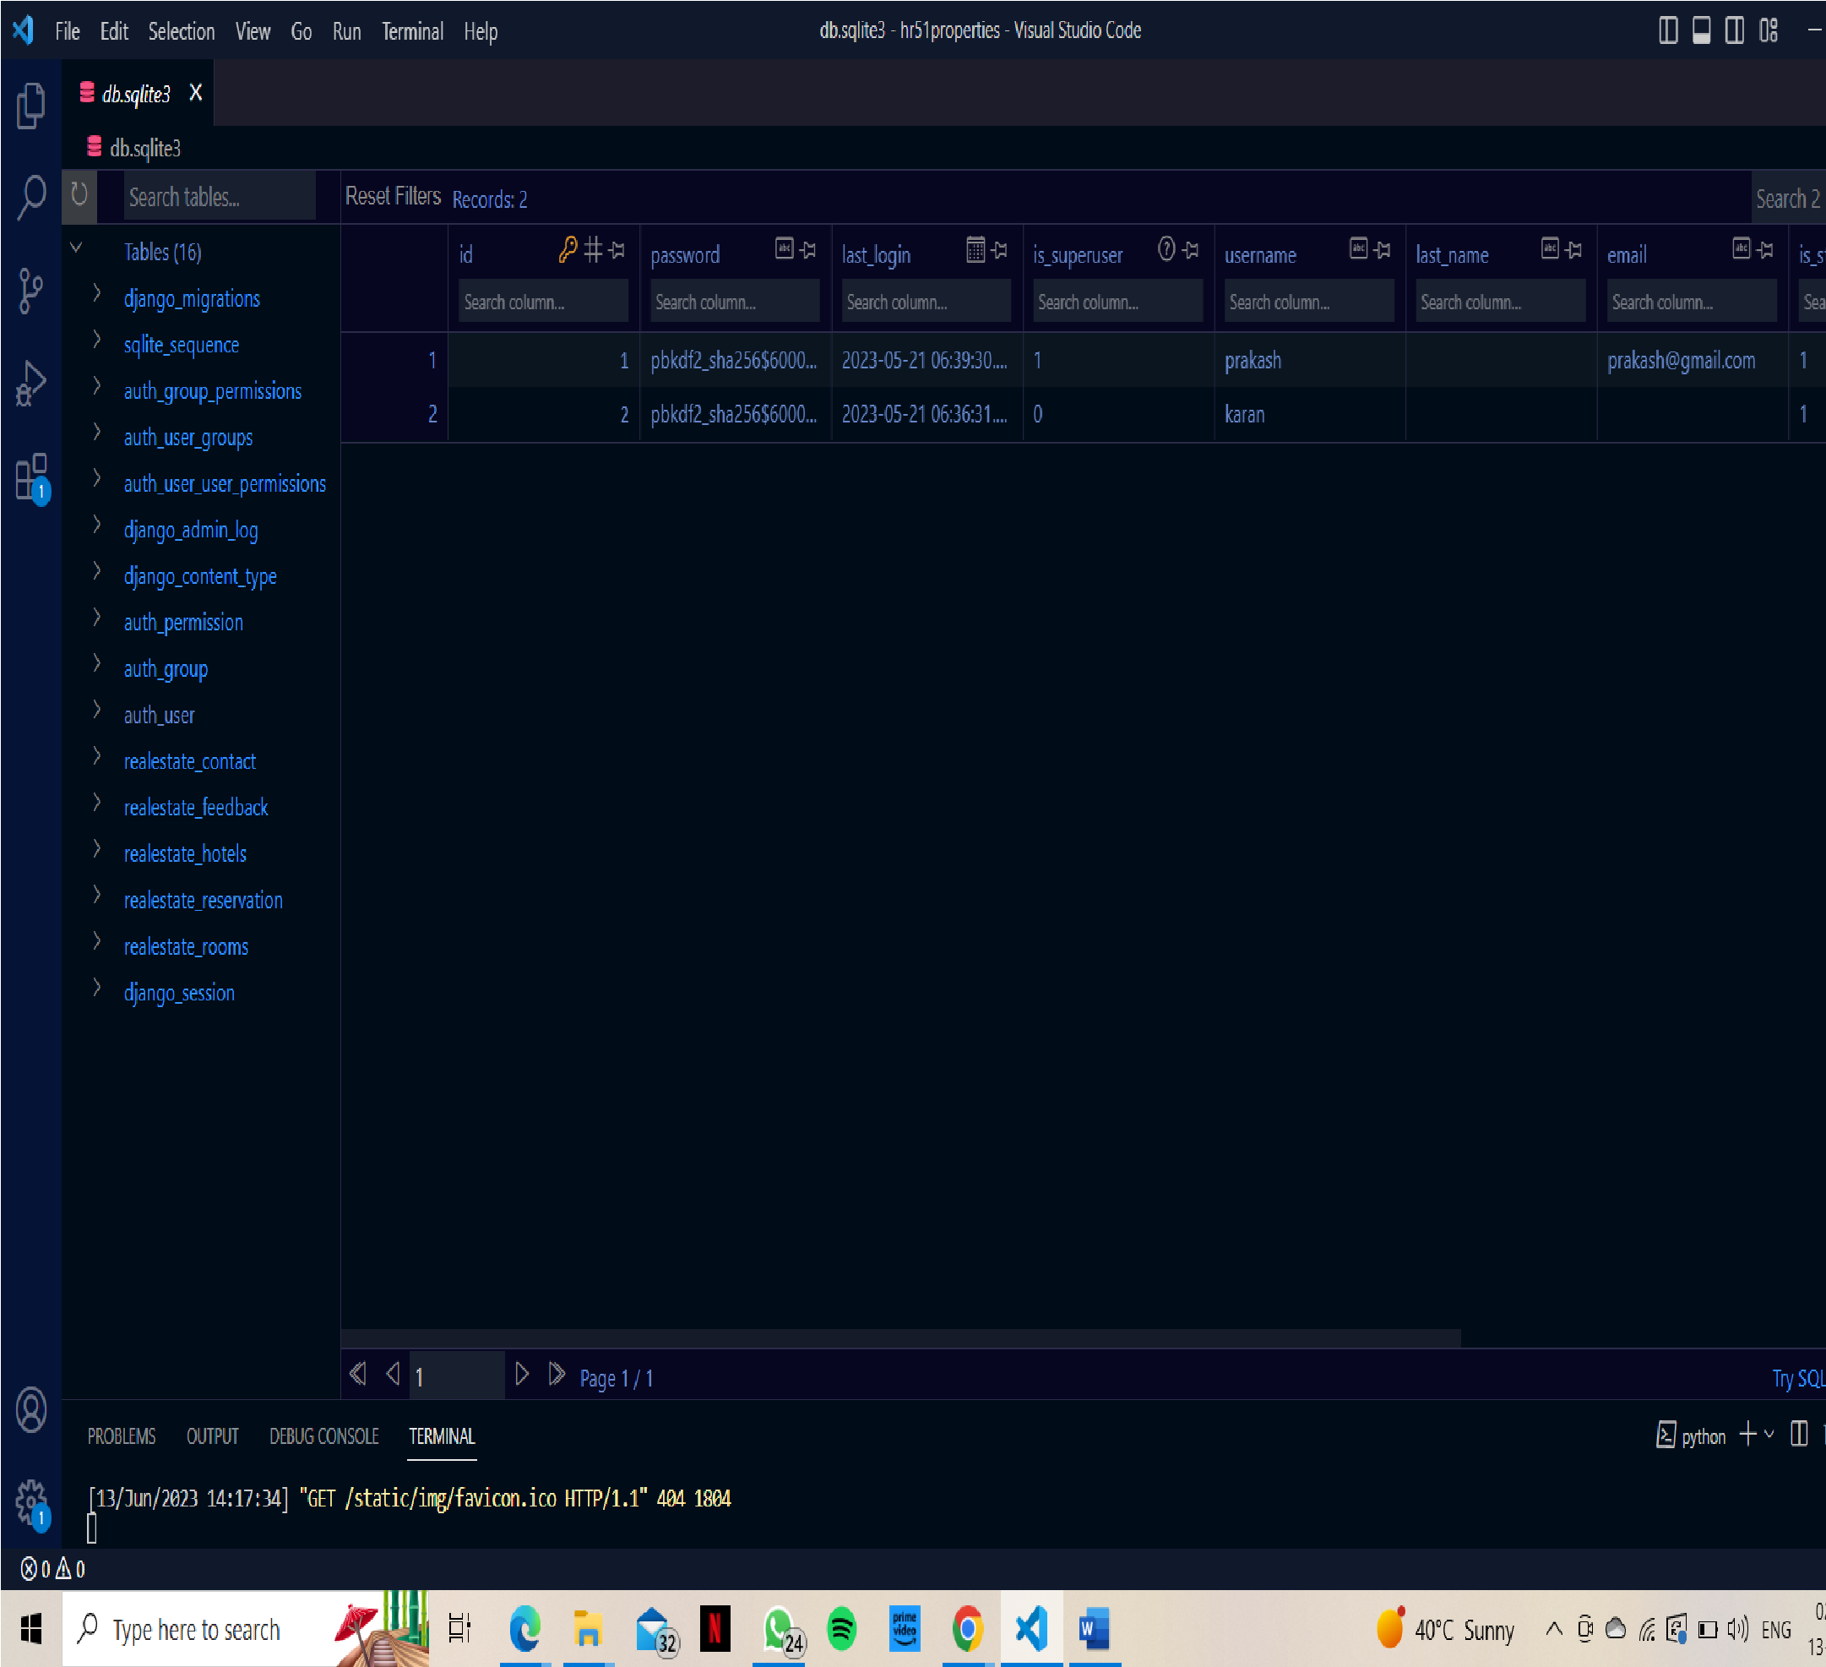

# CHAPTER 5 TESTING & TEST RESULTS

## Chapter 5- TESTING & TEST RESULTS

#### Testing Phase

* + 1. **Unit Testing:**
* Unit testing should be done on the individual units of the system providing accuracy from the lowest level of the system.
* It tests the features including the following:
  + 1. Testing all the login and registration forms for all the cases like invalid id, password, approved, rejected, etc.
    2. Data from the database is fetched correctly and is displayed accordingly.
    3. Testing all the forms and other features.

#### Integration Testing:

Integration testing must be done on the parts of the system providing which comprises the individual units together.

* Prepare Test Data: Prepare test data that represents various scenarios relevant to the real estate module. This data should cover different property types, user profiles, property listings, and any other data required for the integration testing.
* Execute Test Cases: Execute the defined test scenarios to verify the integration of the real estate module with other components. This includes performing actions such as creating property listings, retrieving property details, updating property information, and validating the expected outcomes.

#### User Acceptance Testing:

* + User acceptance testing should be performed by the actual end users with the assistance of the test manager and development team leader. Prior to final completion of acceptance testing all open critical and major defects must be corrected and verified by the Customer test representative. A limited number of distributors will participate in the initial acceptance test process. This is done for the following purposes:
    1. Business Functionality
    2. Integrity
    3. Reporting

### TESTING ACTIVITIES

* + **Project Initiation**: Testing Targets are set during this phase. This phase can last anywhere from several hours to several weeks depending on the nature of the project and the culture of the organization. From the point of view of testing the main tasks are to organize the approach towards testing and start setting up your testing environment if it doesn't already exist. Initial requirements envisioning is done based on which test cases are generated. As the result one gets better understanding of the scope, all of this is important information which should help to decide how much testing we will need to do.
  + **Development Team Testing**: Whole team strategy is followed where people with testing skills are effectively embedded into the development team and the team is responsible for the majority of the testing. This strategy works well for most situations.

### INTEGRATION TESTING

For use, integration tests are basically the same as the unit tests just without using the stubs and drivers. Integration testing is performed on functional units which are integrated at same level or at different Levels. It basically checks the coupling within the unity Functionalities

### SYSTEM TESTING

Under this the whole system is tested under the development team. Each of the functionalities as per requirements is tested here.

### ACCEPTANCE TESTING

User acceptance testing should be performed by the actual end users with the assistance of the test manager and development team leader. Prior to final completion of acceptance testing all open critical and major defects must be corrected and verified by the Customer test representative. A limited number of distributors will participate in the initial acceptance test process.

This is done for the following purposes:

* Business Functionality
* Integrity

### UNIT TESTING

Developers write individual module’s test cases to test various functionalities of a module.

**Testing:** Various tests were conducted for the validations/functionalities of different modules and the result of those test cases along with details is given below:

* Testing the Customer Registration form

|  |  |  |
| --- | --- | --- |
| **VALIDATIONS FOR CUSTOMER REGISTRATION FORM** | | |
| **CASE:** | **Verifies the form for all the validations mentioned below: -** | **POSITIVE** |
| 1 | User can sign up with all the information. | |
| 2 | All the fields are required fields. | |
| 3 | Phone number should be equal to 10 digits. | |
| 4 | Email Id should be valid with all essential parts. | |
| 5 | Name should not be greater than 25 characters. | |
| 6 | Password should not be less than 6 characters. | |
| 7 | Name should not be less than 2 characters. | |
| 8 | On entering proper data, clicking the submit button will submit the form and redirected to login form. | |
| 9 | Form will not get submitted and shows error if any data is invalid. | |

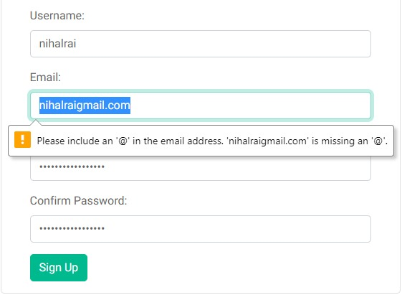

Testing the registration module for the user’s registrations by entering incomplete information. It is showing a pop up while entering the wrong details or incomplete information.

* Testing the Login form (Customer)

|  |  |  |
| --- | --- | --- |
| **VALIDATIONS FOR LOGIN FORM (CUSTOMER)** | | |
| **CASE:** | **Verifies the form for all the validations mentioned below: -** | **POSITIVE** |
| 1 | User can login with registered email and correct password. | |
| 2 | User cannot login with unregistered email or incorrect password. | |
| 3 | Email Id should be valid with all essential parts. | |
| 4 | All the fields are required fields. | |
| 5 | On entering proper data and getting approved by the admin, only then they may be able to login and redirected to main home page of the website. | |
| 6 | Form will not get submitted and shows error if any data is invalid. | |
| 7 | If customer’s status is rejected, it will lead to login page again. | |
| 8 | If customer’s status is approved, it will lead to website home page. | |

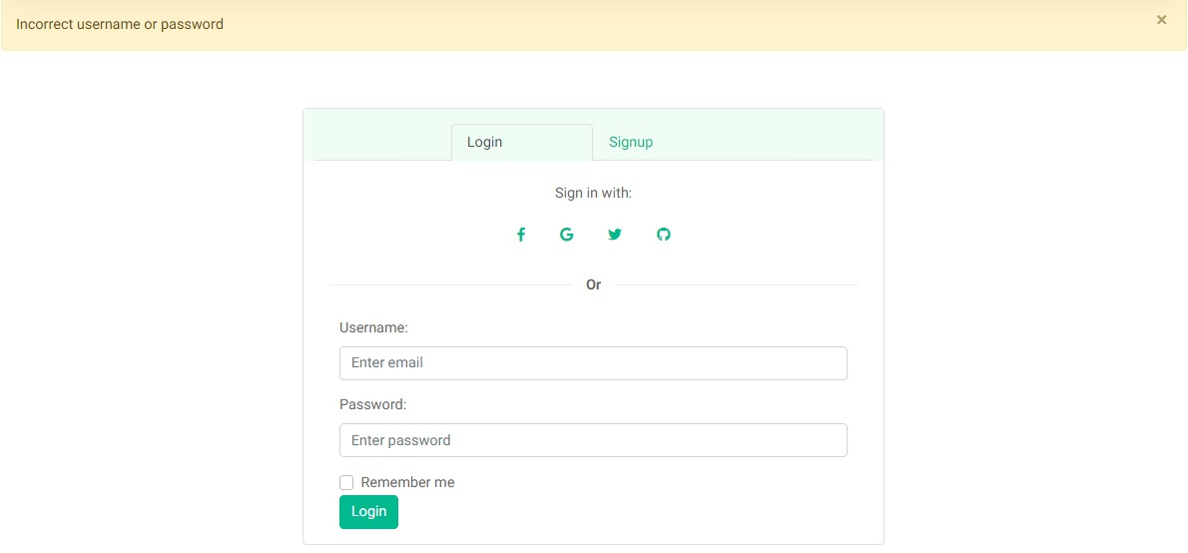

Testing the user’s login module by entering the correct information and it’s redirecting to the home screen without any error.

* Testing the Login form (Staff)

|  |  |  |
| --- | --- | --- |
| **VALIDATIONS FOR LOGIN FORM (STAFF)** | | |
| **CASE:** | **Verifies the form for all the validations mentioned below: -** | **POSITIVE** |
| 1 | User can login with registered email and correct password. | |
| 2 | User cannot login with unregistered email or incorrect password. | |
| 3 | Email Id should be valid with all essential parts. | |
| 4 | All the fields are required fields. | |
| 5 | On entering proper data and getting approved by the admin, only then they may be able to login and redirected to the staff panel. | |
| 6 | Form will not get submitted and shows error if any data is invalid. | |
| 7 | If Staff member’s status is rejected, it will lead to login page again. | |
| 8 | If Staff member’s status is approved, it will lead to staff’s panel. | |

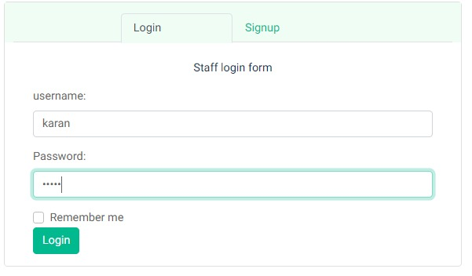

Testing the login module with the staff user’s details and it’s working correctly. Taken Karan as the username that has already been registered into the database.

* Testing the Admin Login

|  |  |  |
| --- | --- | --- |
| **VALIDATIONS FOR ADMIN LOGIN** | | |
| **CASE:** | **Verifies the form for all the validations mentioned below: -** | **POSITIVE** |
| 1 | User can login to the Admin panel with registered email and correct password. | |
| 2 | User cannot login to the Admin panel with unregistered email or incorrect password. | |
| 3 | Email Id should be valid with all essential parts. | |
| 4 | All the fields are required fields. | |
| 5 | Form will not get submitted and shows error if any data is invalid. | |
| 6 | On entering proper data, clicking the submit button will submit form and redirected to admin panel. | |

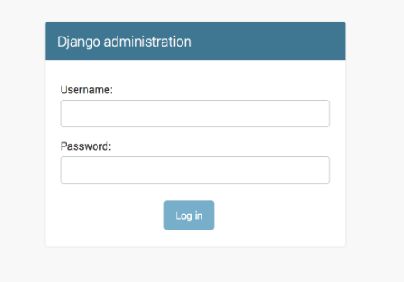

Testing admin login whether it’s working or not correctly with the admin details that has already been entered into the database.

* Testing the Contact us form

|  |  |  |
| --- | --- | --- |
| **VALIDATIONS FOR CONTACT US FORM** | | |
| **CASE:** | **Verifies the form for all the validations mentioned below: -** | **POSITIVE** |
| 1. | All the fields are mandatory. | |
| 2. | Subject of the Query should be greater than 2 characters. | |
| 3. | Phone number should be equal to 10 digits | |
| 4. | Email Id should be valid with all essential parts. | |
| 5 | Name should not be greater than 25 characters | |
| 6. | On entering proper data, clicking the submit button will submit form. | |
| 7. | Form will not get submitted and shows error if any data is invalid. | |

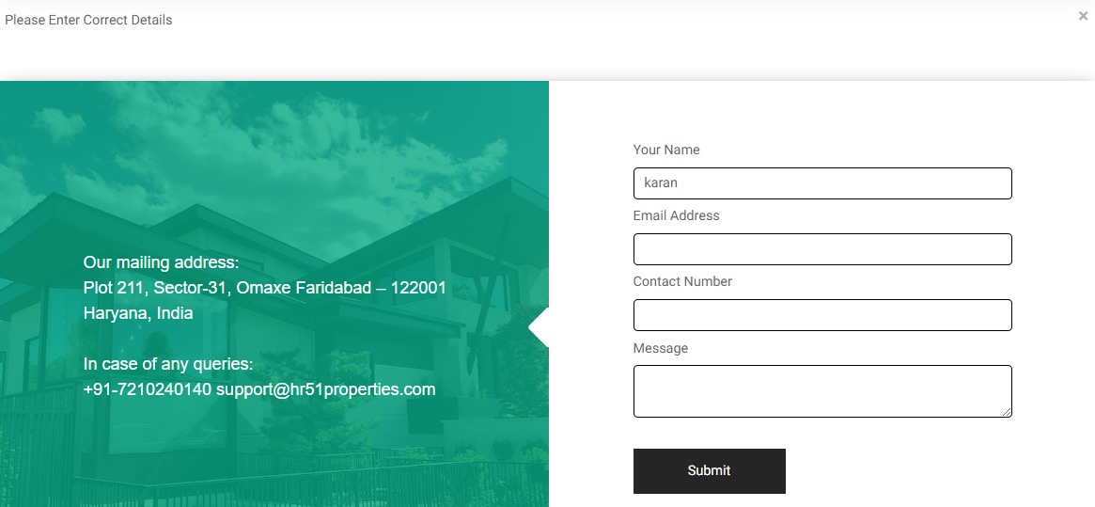

Testing the contact us page by entering the details and testing it’s functionality.

* Testing the Landing Page

|  |  |  |  |  |
| --- | --- | --- | --- | --- |
| **#Step** | **Step Details** | **Expected Results** | **Actual Results** | **Pass/Fail** |
| 1 | Click My profile button | Profile should open | As Expected | Pass |
| 2 | Click settings button | Settings should open | As Expected | Pass |
| 3 | Click Terms and conditions button | Terms and conditions should open | As Expected | Pass |
| 4 | Click privacy policy button | Privacy policy should open | As Expected | Pass |
| 5 | Click about us button | About us page should open | As Expected | Pass |
| 6 | Click logout button | User should logout and return to login screen | As Expected | Pass |
| 7 | Go on Residents list | Screen with Residents’ list should appear | As Expected | Pass |
| 8 | Go on Guests List | Screen with two buttons , one for guests In and one for  guests OUT should appear with list of guests | As Expected | Pass |

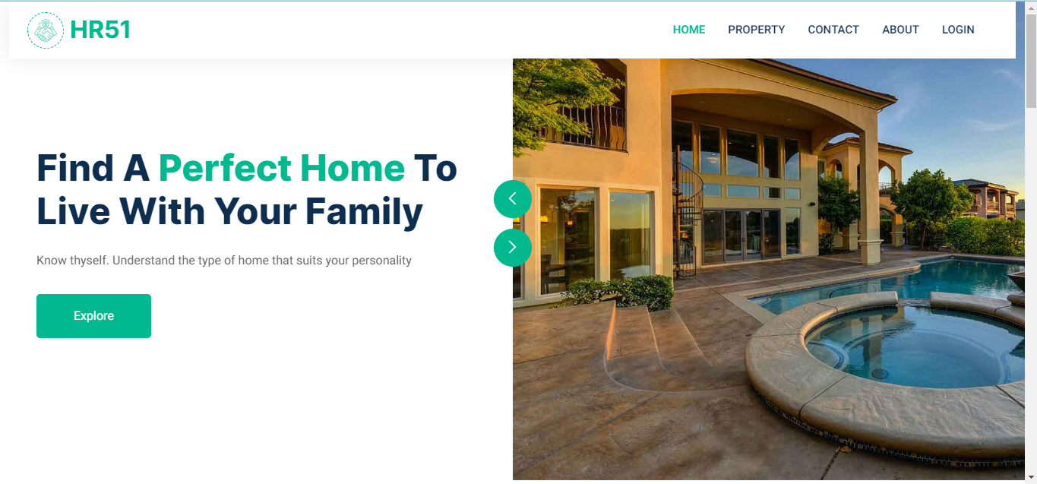

Testing the home page whether all the modules are working or not.

# CHAPTER 6 RESULTS & CONCLUSION

## Chapter 6- RESULTS & CONCLUSION

The system offers a comprehensive end-to-end solution, encompassing various functionalities. It efficiently manages the entry and exit of visitors, streamlines the pre-approval process for guests, and ensures seamless visitor notifications. The application's capabilities meet the requirements for smooth visitor management and enhance the overall visitor experience.

The technical advantages of the application are:

1. Streamlined Property Management: The real estate application provides a centralized platform for managing properties efficiently. It allows users to easily add, update, and track property listings, including details such as location, specifications, pricing, and availability. This streamlines the property management process and ensures accurate and up-to-date information.

2. Enhanced Search and Filtering: The application offers advanced search and filtering capabilities, allowing users to quickly find properties that meet their specific criteria. Users can search by location, property type, price range, amenities, and more, enabling them to narrow down their options and find relevant properties with ease.

3. User-Friendly Interface: The real estate application is designed with a user-friendly interface, making it intuitive and easy to navigate for both administrators and users. The interface is visually appealing, with clear menus, intuitive forms, and interactive features that enhance the overall user experience.

4. Property Listing Management: The application provides a comprehensive backend system for property listing management. Real estate agents or staff members can easily add, edit, and update property listings, including property details, images, descriptions, and other relevant information.

5. Responsive Design: The application is built with a responsive design, ensuring that it adapts seamlessly to different devices and screen sizes. Whether users access the application from a desktop computer, tablet, or mobile device, they can enjoy a consistent and optimized experience.

### FUTURE SCOPE

Creating a positive first impression is crucial in both human relationships and human-computer interaction. Understanding the significance of time and the emerging trends of task automation in the IT industry, our project aims to develop a cutting-edge application that enables societies to effortlessly and efficiently carry out their tasks. While we have developed the "HR51-Properties" application with great care, we recognize that there is always room for improvement.

With that in mind, we envision expanding the application in the future to offer additional services and features that will further enhance its usefulness and convenience for users. Some of the potential features we may include are:

1. Advanced Property Search: Enhancing the search functionality to provide users with more refined and personalized property search options, such as advanced filters, saved searches, and property comparison tools.

2. Interactive Property Listings: Enriching property listings with interactive elements, such as 360-degree virtual tours, high-resolution images, and detailed floor plans, to provide a more immersive and informative browsing experience for users.

3. Online Property Transactions: Facilitating secure online transactions, including property reservations, booking appointments, and online document signing, to streamline the buying, selling, and renting processes for users.

4. Neighborhood Information: Incorporating comprehensive neighborhood information, such as nearby amenities, schools, transportation options, and crime rates, to help users evaluate the suitability of a property based on their specific preferences and needs.

5. Property Management Tools: Introducing property management features for property owners and landlords, including rent collection, tenant communication, maintenance tracking, and financial reporting, to simplify the management of their properties.

### REFERENCES/BIBLIOGRAPHY

* + - <https://www.javatpoint.com/python>
    - <https://www.javatpoint.com/django>
    - <https://www.javatpoint.com/admin-work>
    - <https://www.javatpoint.com/admin-work>
    - <https://www.javatpoint.com/canvaworld>